**Customize NIEHS Career Outcome Data Dashboard**

In January 2018, the NIEHS [Office of Fellows’ Career Development](https://www.niehs.nih.gov/careers/research/fellows/index.cfm) (OFCD) team published a paper [in the journal Nature Biotechnology](https://www.nature.com/articles/nbt.4059) on the career outcomes of about 900 NIEHS postdoctoral alumni from 2000 to 2014. Then we developed an [interactive dashboard](https://www.niehs.nih.gov/careers/research/fellows/alumni-outcomes/index.cfm) to visualize the NIEHS alumni career outcome data in this 15-year time span. Later, we released the R Shiny code of the career outcome dashboard as [open source software on GitHub](https://github.com/nihxuh/alumni-shiny).

In the meantime, we worked closely with Wayne State University Graduate School to customize the NIEHS career outcome dashboard software for visualizing the career outcomes of about 870 biomedical alumni of Wayne State University. Here we document the software customization process to provide instructions for other people who’d like to use our program to visualize the career outcomes of their trainees.

**Programming Environment**

Before you start customizing the NIEHS career outcome dashboard, you need to set up the programming environment. Please follow the instructions below to install the software programs.

*R*

R is a programming language and free software environment for statistical computing and graphics supported by the R Foundation for Statistical Computing. You can download the latest *R* software from the [*R* Project website](https://www.r-project.org/).

*RStudio*

*RStudio* is a free and open-source integrated development environment for R. It includes a console, syntax-highlighting editor that supports direct code execution, as well as tools for plotting, history, debugging and workspace management. From [Download RStudio](https://www.rstudio.com/products/rstudio/download/#download) page choose the appropriate installer file for your operating system, download it and then run it to install R-studio.

*R Packages*

NIEHS career outcome dashboard requires some *R* packages to be installed in *RStudio*. Please follow the steps below to install them,

1. Run RStudio
2. In the bottom-left “Console” tab window, type the following command line and hit “return” key

install.packages(c('devtools','reshape2','data.table','tidyverse','ggplot2','ggrepel',

'scales','stringr','migest','RColorBrewer','circlize','choroplethr','choroplethrMaps',

'dplyr','shinydashboard','plotly','sunburstR'), repos='https://cran.rstudio.com/')

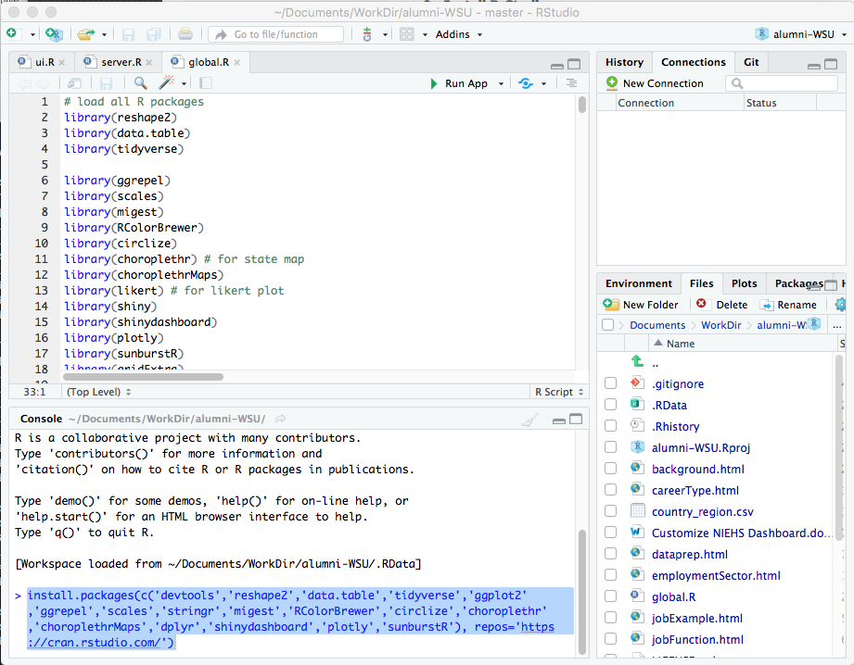

1. In the bottom-left “Console” tab window, type the following command line and hit “return” key

devtools::install_github('m-dev-/likert')

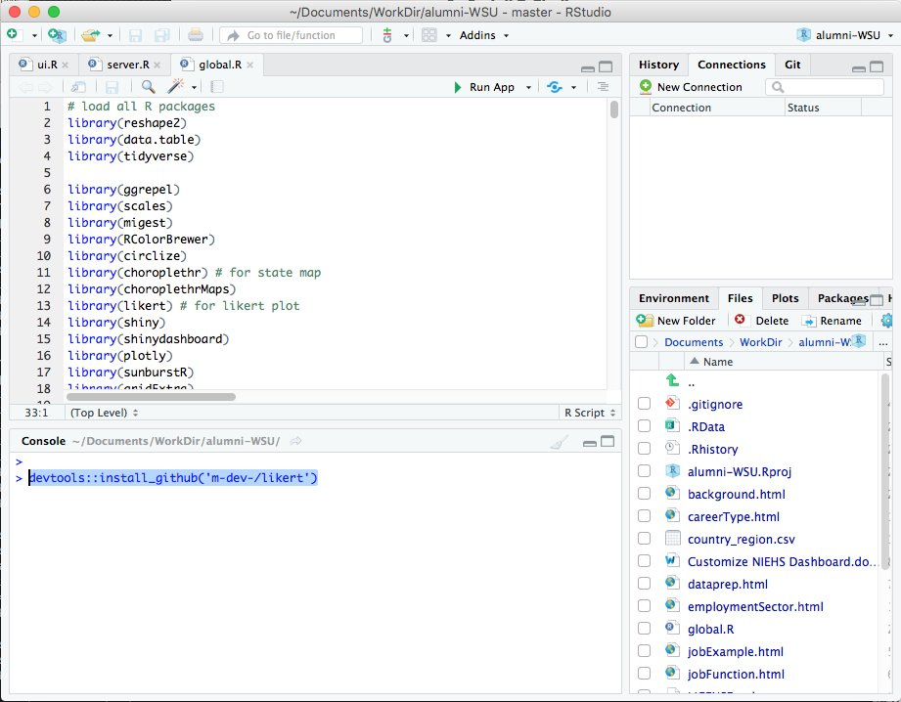

*Git*

[*Git*](https://git-scm.com/) is a version-control system for tracking changes in computer files and coordinating work on those files among multiple people. It is primarily used for source-code management in software development, but it can be used to keep track of changes in any set of files. You can use *Git* to get NIEHS career outcome dashboard software from [GitHub](https://github.com/), a web-based hosting service for version control using Git. Please follow [the instruction](https://git-scm.com/book/en/v2/Getting-Started-Installing-Git) to install *Git* on your computer.

**Start Career Outcome Dashboard Project**

After installing the required software programs, you can create the dashboard customization project easily by using *RStudio* with *Git*. Before you start, please read the detail instruction on “[Using Version Control with RStudio](https://support.rstudio.com/hc/en-us/articles/200532077?version=1.1.456&mode=desktop)” from *RStudio* Support. Then you can follow the simple steps below to create the project.

1. Run RStudio
2. From “File” drop-down menu, choose “New Project…”

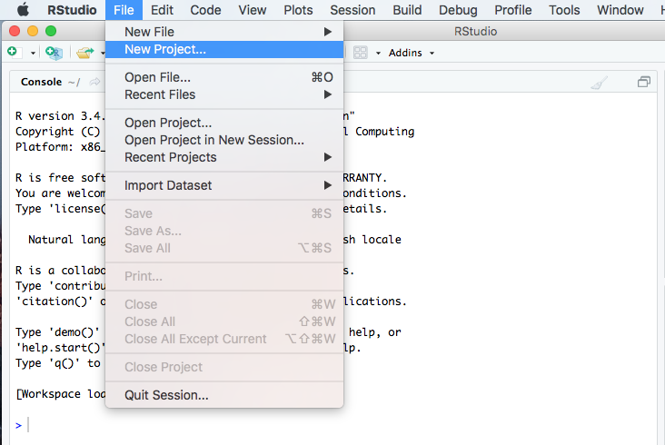

1. From “**Create Project**” pop-up dialogue, choose “**Version Control**”

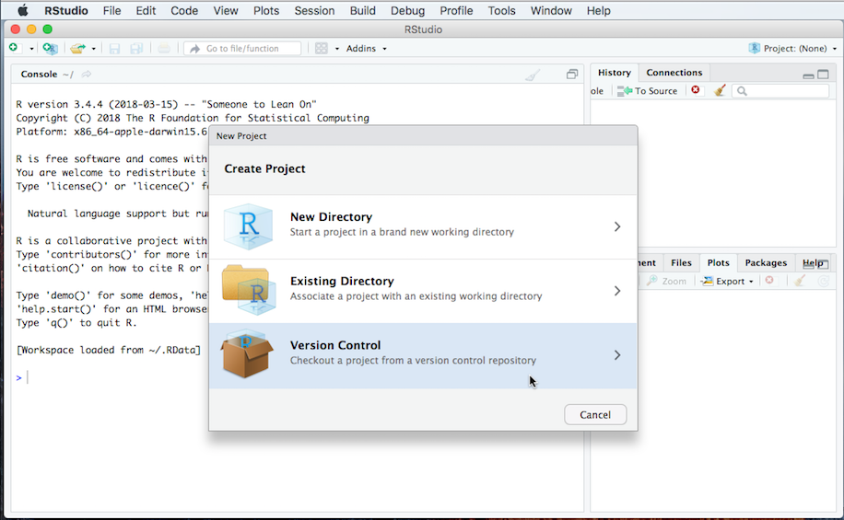

1. From “**Create Project**” pop-up dialogue, choose “**Version Control**”

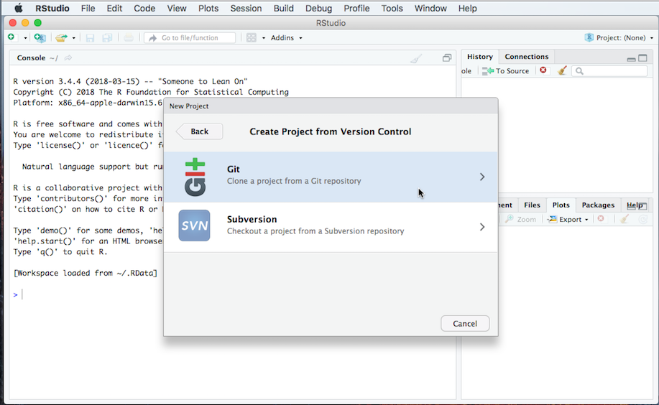

1. From “**Clone Git Repository**” pop-up dialogue, type https://github.com/nihxuh/alumni-customization.git in “Repository URL:” field, then type project name (such as Dashboard) in “Project directory name:” field, choose the directory (such as ~/Documents) at “Create project as subdirectory of:” field, and click “**Create Project**” button.

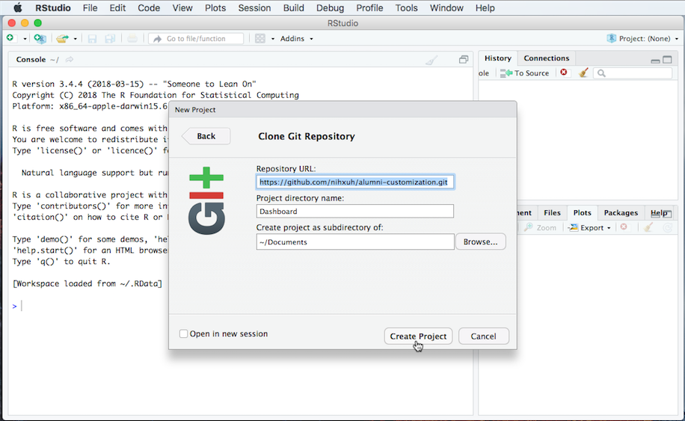

1. RStudio will copy all the program files from GitHub repository [nihxuh/**alumni-customization**](https://github.com/nihxuh/alumni-customization)**.** You should see all the files when you click the “**Files**” tab. Then you can start customize the dashboard code by following the instructions in the rest of the document.

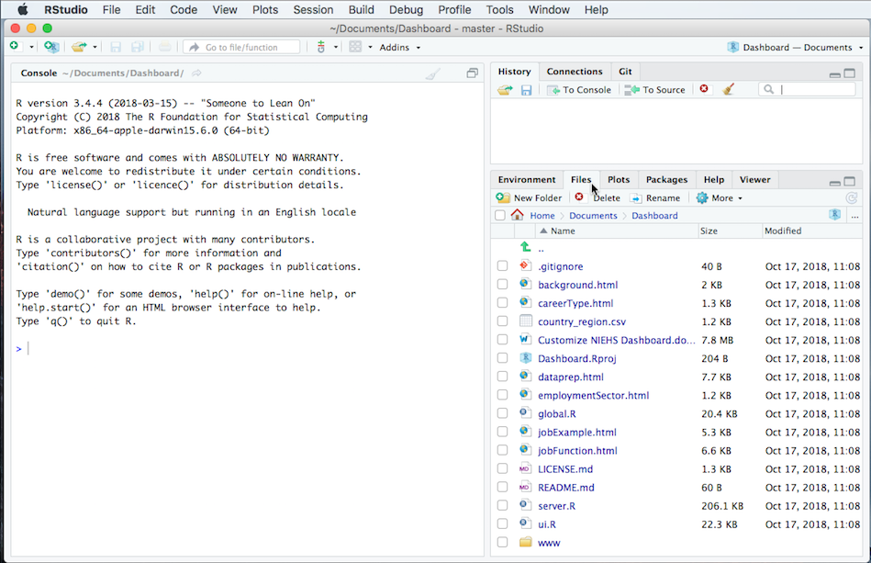

**Data Tables**

*Source data*

The NIEHS career outcome dashboard program takes Excel spreadsheets as input data source. The Excel spreadsheets have data fields with predefined header names for the program to be functional. Below is the table of data fields in [NIEHS source data](https://www.niehs.nih.gov/careers/research/fellows/alumni-outcomes/sourcedata.csv) (Table 1).

|  |  |
| --- | --- |
| **Header_Name** | **Note** |
| institute | Institute name |
| gender | Gender information: "Male" or "Female" |
| country_origin | Trainee's original country |
| citizenship | Citizenship information: "US" or "International" |
| months_postdoc | Training time in months |
| job_sector | Career taxonomy tier 1: job sector |
| job_type | Career taxonomy tier 2: job type |
| specifics | Career taxonomy tier 3: job specifics |
| job_country | Job location - country |
| job_state | Job location - state (in US) or city (international) |
| degree | doctoral degree: "PhD", "MD", "MD;PhD", "DVM", "DVM;PhD", 'PhD;JD", "PhD;MPHYR", ect. |
| degree_cip | degree field [categorized by Classification of Instructional Programs (CIP) from the U.S. Department of Education's National Center for Education Statistics (NCES)] |
| years | Year ranges |

Table 1. Data fields of NIEHS source data

You can change these header names if you modify the corresponding code in the dashboard program. You can also add new data fields with new header names if you add new visualization code modules for the new data fields. We will discuss how to do this later in this customization guide. Below is the table of data fields in Wayne State University (WSU) source data (Table 2). The yellow-highlighted fields are changes compared to NIEHS source data.

|  |  |
| --- | --- |
| **Header_Name** | **Note** |
| institute | Institute name |
| gender | Gender information: "Male" or "Female" |
| country_origin | Trainee's orginal country |
| citizenship | Citizenship information: "Citizen", "Non-Citizen" or "Permanent Resident" |
| job_sector | Career taxonomy tier 1: job sector |
| career_type | Career taxonomy tier 2: career type |
| job_function | Career taxonomy tier 3: job function |
| job_country | Job location - country |
| job_state | Job location - state (in US) |
| school | Graduate school name |
| department | Department name |
| major | Graduate study major (similar to “degree_cip” in Table 1) |
| train_time | Training time in years |
| inst_gpa | GPA |
| race | race information: "Asia", "Black or African American", "white", or "Race Not Reported" |
| funding | Funding information: "Yes" or "No" |
| years | Year ranges |

Table 2. Data fields of WSU source data

*Country-Region data*

The NIEHS career outcome dashboard program uses [circular migration plot](https://gjabel.wordpress.com/2016/05/18/updated-circular-plots-for-directional-bilateral-migration-data/) to show the trainee migration flows between countries (Figure 1). To make the plot look better, we reduce number of countries by grouping countries with few alumni into continent regions. See Table 3 for mapping the country names to region names.

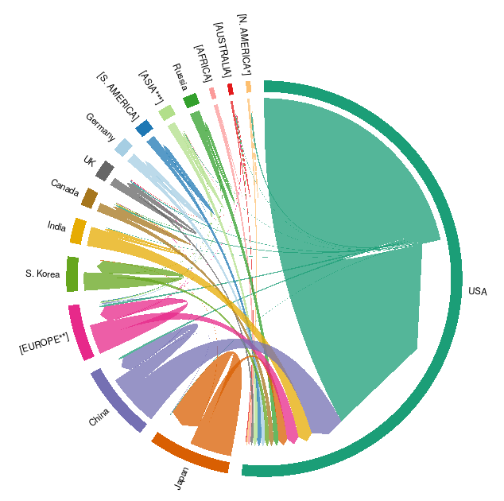

Figure 1. NIEHS alumni migration plot

|  |  |
| --- | --- |
| **Country** | **Region** |
| Argentina | [S. AMERICA] |
| Australia | [AUSTRALIA] |
| Belarus | [EUROPE**] |
| Belgium | [EUROPE**] |
| Brazil | [S. AMERICA] |
| Cameroon | [AFRICA] |
| Canada | Canada |
| Chile | [S. AMERICA] |
| China | China |
| Colombia | [S. AMERICA] |
| Czech Republic | [EUROPE**] |
| Denmark | [EUROPE**] |
| Finland | [EUROPE**] |
| France | [EUROPE**] |
| Germany | Germany |
| Hungary | [EUROPE**] |
| India | India |
| Indonesia | [ASIA***] |
| Iran | [ASIA***] |
| Ireland | [EUROPE**] |
| Israel | [ASIA***] |
| Italy | [EUROPE**] |
| Japan | Japan |
| Kenya | [AFRICA] |
| Malaysia | [ASIA***] |
| Mexico | [N. AMERICA*] |
| Mongolia | [ASIA***] |
| Morocco | [AFRICA] |
| Netherlands | [EUROPE**] |
| New Zealand | [AUSTRALIA] |
| Norway | [EUROPE**] |
| Pakistan | [ASIA***] |
| Poland | [EUROPE**] |
| Puerto Rico | USA |
| Qatar | [ASIA***] |
| Romania | [EUROPE**] |
| Russia | Russia |
| Saudi Arabia | [ASIA***] |
| Slovak Republic | [EUROPE**] |
| South Africa | [AFRICA] |
| South Korea | S. Korea |
| Spain | [EUROPE**] |
| Sweden | [EUROPE**] |
| Switzerland | [EUROPE**] |
| Taiwan | [ASIA***] |
| Tatarstan | [ASIA***] |
| Thailand | [ASIA***] |
| Turkey | [EUROPE**] |
| United Kingdom | UK |
| United States | USA |
| Unknown | Unknown |
| Vietnam | [ASIA***] |
| West Indies | [N. AMERICA*] |
| Zimbabwe | [AFRICA] |

Table 3. Country-to-Region mapping data

**Code Customization**

If you have career outcome data similar to [NIEHS source data](https://www.niehs.nih.gov/careers/research/fellows/alumni-outcomes/sourcedata.csv) and you use the NIEHS 3-tier career taxonomy to categorize the career outcomes, you don’t need to any code customization. You just save your source data as “sourceData.csv” and put it in the main code directory, then the dashboard program will work to display the career outcome data.

We will show code customization by showing the dashboards of NIEHS data and WSU data side by side. We will indicate which code section needs to be changed to make the customization differences.

*Main page*

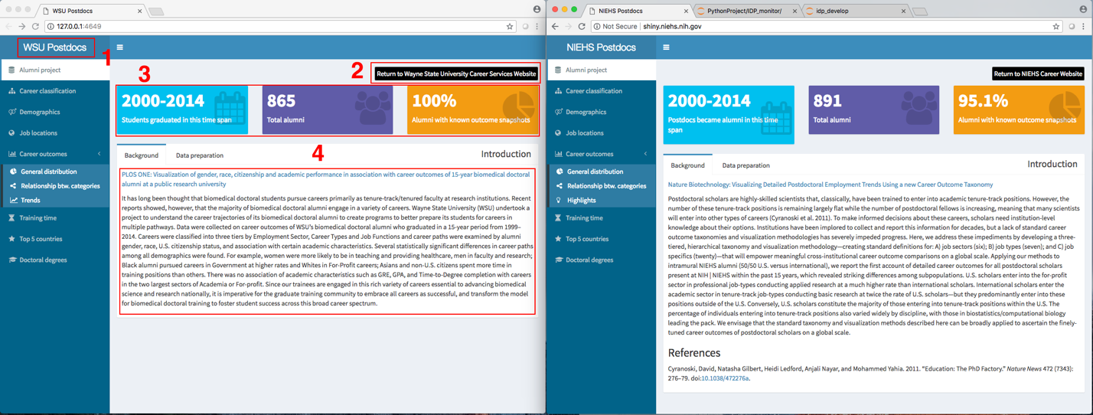

Figure 2. Dashboard main page

1. Dashboard title: the dashboard title is defined by the value in the “institute” field of the source data table.

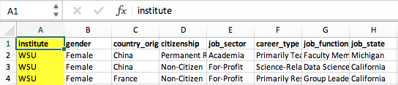

1. Link to home URL: the URL link back to home page or upper level page. It is defined by the code section in the global environment program – “global.R” (see the code section below).

NIEHS code:

# Link out text label and javascript

linkText = "Return to NIEHS Career Website"

linkJScript = "javascript:parent.window.location.href='https://www.niehs.nih.gov/careers/research/fellows/index.cfm'"

WSU code:

# Link out text label and javascript

# Here we use 'Google Career Website' and its URL 'https://careers.google.com/' as example

# Please replace this with your own values

linkText = "Return to Google Career Website"

linkJScript = "javascript:parent.window.location.href='https://careers.google.com/'"

The URL link definitions are called by the code section appeared several rimes in the user interface program – “ui.R” (see the code section below).

fluidRow(

column(12, align="right",

actionButton(inputId = "goHome", label = linkText, class="pre_anchor",

onclick = linkJScript),

HTML("<p></p>")

)

),

1. Data summary: the summary of career outcome data, including “time span”, “number of alumni” and “percentage of alumni with known career outcomes”. It is calculated automatically by the program, and no code changes are needed.
2. Background: the background information of data dashboard. It is an HTML file – “background.html” included in the user interface program – “ui.R.” Its content needs to be modified to match your dashboard background.

*Data preparation page*

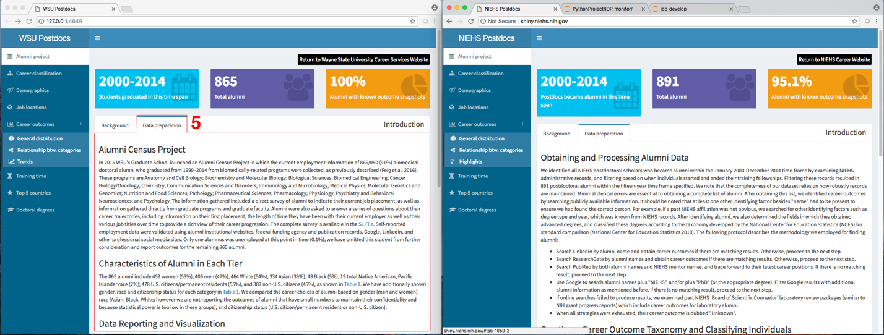

Figure 3. Data preparation page

1. Data preparation: the data preparation information. It is an HTML file – “dataprep.html” included in the user interface program – “ui.R.” Its content needs to be modified to match your dashboard background.

*Career taxonomy page – tier 1*

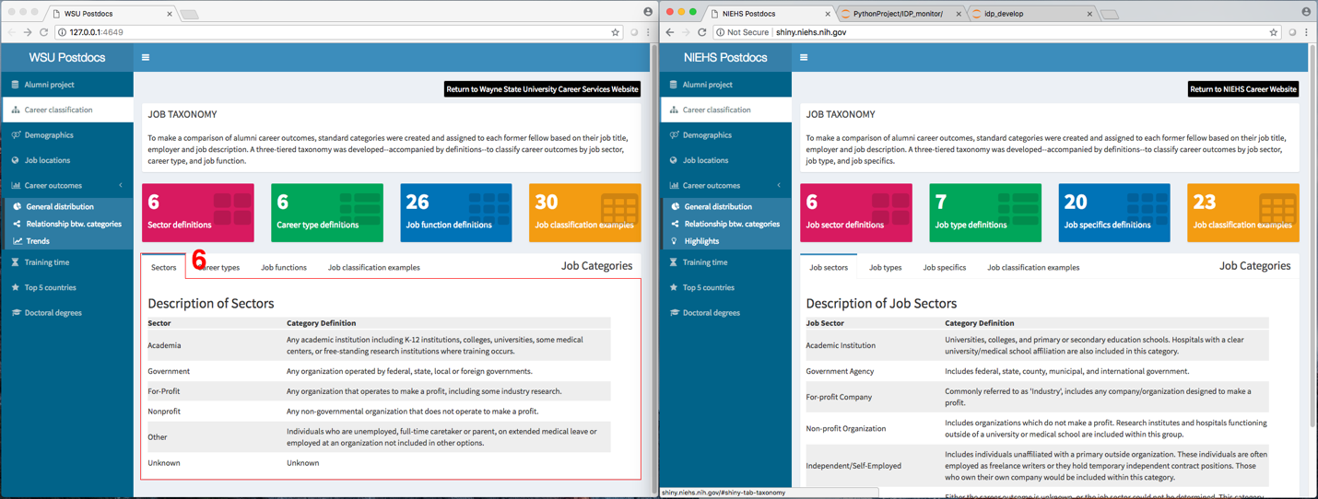

Figure 4. Career taxonomy tier 1 – employment sector / job sector

1. Career taxonomy tier 1: the first tier of 3-tier career taxonomy. It is an HTML file – “jobSect.html” (NIEHS version) or “employmentSector.html” (WSU version) included in the user interface program – “ui.R.” Its content needs to be modified to match the definition of your career taxonomy tier 1 - job sector (see the code section below).

NIEHS code:

fluidRow(

tabBox(

title = "Job Categories",

# The id lets us use input$tabset2 on the server to find the current tab

id = "tabset2", width = 12,

tabPanel("Job sectors", includeHTML("jobSect.html")),

tabPanel("Job types", includeHTML("jobType.html")),

tabPanel("Job specifics", includeHTML("jobSpec.html")),

tabPanel("Job classification examples", includeHTML("jobExample.html"))

)

WSU code:

fluidRow(

tabBox(

title = "Job Categories",

# The id lets us use input$tabset2 on the server to find the current tab

id = "tabset2", width = 12,

tabPanel("Job sectors", includeHTML("employmentSector.html")),

tabPanel("Job types", includeHTML("careerType.html")),

tabPanel("Job specifics", includeHTML("jobFunction.html")),

tabPanel("Job classification examples", includeHTML("jobExample.html"))

)

*Career taxonomy page – tier 2*

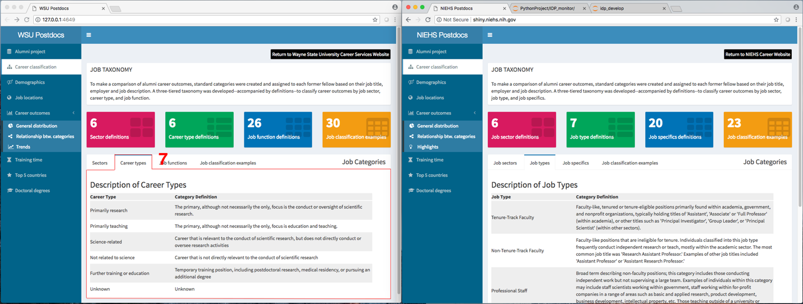

Figure 5. Career taxonomy tier 2 – career type / job type

1. Career taxonomy tier 2: the second tier of 3-tier career taxonomy. It is an HTML file – “jobType.html” (NIEHS version) or “careerSector.html” (WSU version) included in the user interface program – “ui.R.” Its content needs to be modified to match the definition of your career taxonomy tier 2 - job type (see the code section below).

NIEHS code:

fluidRow(

tabBox(

title = "Job Categories",

# The id lets us use input$tabset2 on the server to find the current tab

id = "tabset2", width = 12,

tabPanel("Job sectors", includeHTML("jobSect.html")),

tabPanel("Job types", includeHTML("jobType.html")),

tabPanel("Job specifics", includeHTML("jobSpec.html")),

tabPanel("Job classification examples", includeHTML("jobExample.html"))

)

WSU code:

fluidRow(

tabBox(

title = "Job Categories",

# The id lets us use input$tabset2 on the server to find the current tab

id = "tabset2", width = 12,

tabPanel("Job sectors", includeHTML("employmentSector.html")),

tabPanel("Job types", includeHTML("careerType.html")),

tabPanel("Job specifics", includeHTML("jobFunction.html")),

tabPanel("Job classification examples", includeHTML("jobExample.html"))

)

*Career taxonomy page – tier 3*

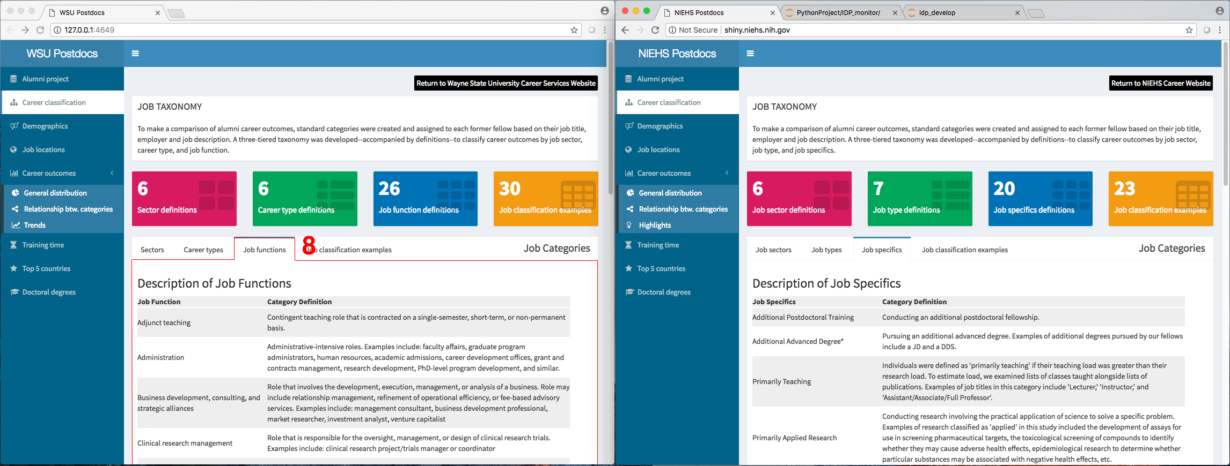

Figure 6. Career taxonomy tier 3 – job function / job specifics

1. Career taxonomy tier 3: the third tier of 3-tier career taxonomy. It is an HTML file – “jobSpec.html” (NIEHS version) or “jobFunction.html” (WSU version) included in the user interface program – “ui.R.” Its content needs to be modified to match the definition of your career taxonomy tier 3 - job specifics or sunction (see the code section below).

NIEHS code:

fluidRow(

tabBox(

title = "Job Categories",

# The id lets us use input$tabset2 on the server to find the current tab

id = "tabset2", width = 12,

tabPanel("Job sectors", includeHTML("jobSect.html")),

tabPanel("Job types", includeHTML("jobType.html")),

tabPanel("Job specifics", includeHTML("jobSpec.html")),

tabPanel("Job classification examples", includeHTML("jobExample.html"))

)

WSU code:

fluidRow(

tabBox(

title = "Job Categories",

# The id lets us use input$tabset2 on the server to find the current tab

id = "tabset2", width = 12,

tabPanel("Job sectors", includeHTML("employmentSector.html")),

tabPanel("Job types", includeHTML("careerType.html")),

tabPanel("Job specifics", includeHTML("jobFunction.html")),

tabPanel("Job classification examples", includeHTML("jobExample.html"))

)

*Career taxonomy page – job classification example*

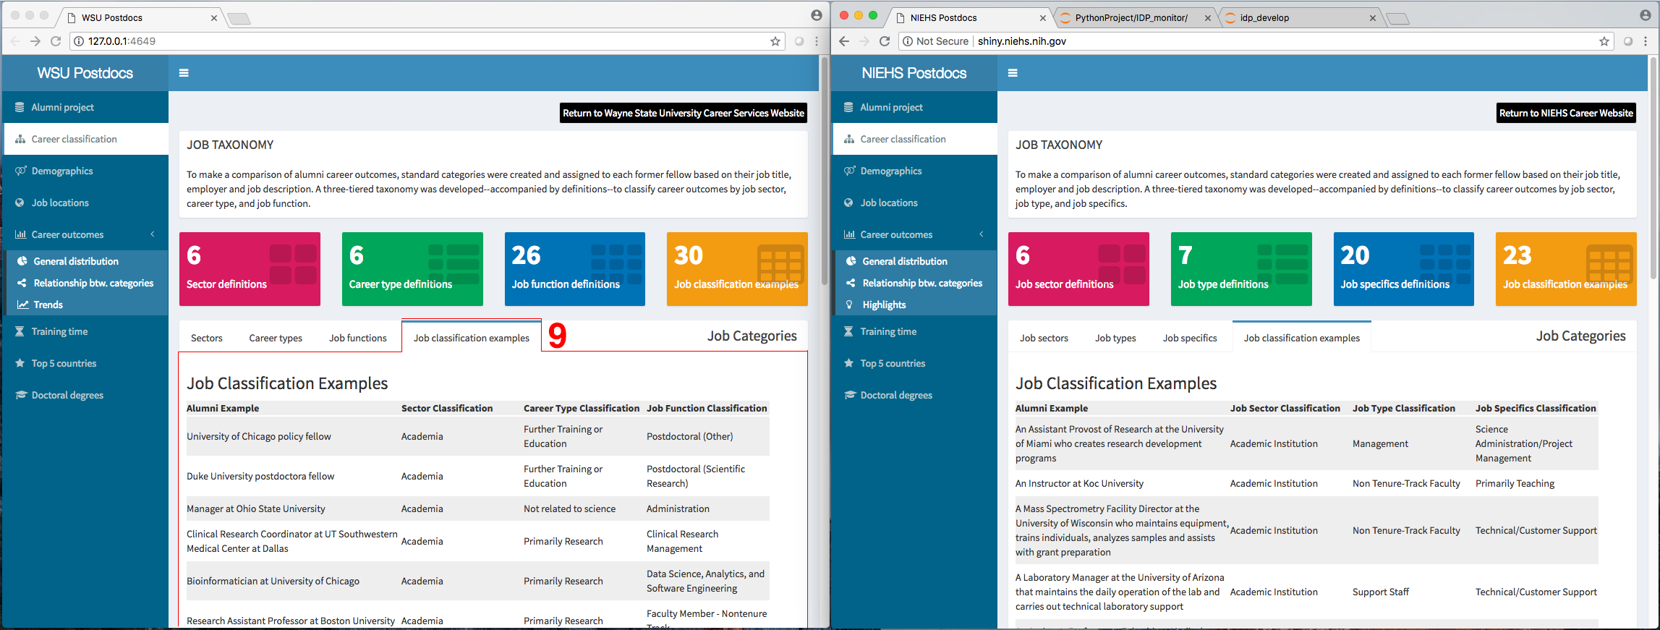

Figure 7. Career taxonomy examples

1. Career taxonomy example: the career classification examples by using the 3-tier career taxonomy. It is an HTML file – “jobExample.html” (NIEHS/WSU versions) included in the user interface program – “ui.R.” Its content needs to be modified to match the definition of your career taxonomy classification examples (see the code section below).

NIEHS code:

fluidRow(

tabBox(

title = "Job Categories",

# The id lets us use input$tabset2 on the server to find the current tab

id = "tabset2", width = 12,

tabPanel("Job sectors", includeHTML("jobSect.html")),

tabPanel("Job types", includeHTML("jobType.html")),

tabPanel("Job specifics", includeHTML("jobSpec.html")),

tabPanel("Job classification examples", includeHTML("jobExample.html"))

)

WSU code:

fluidRow(

tabBox(

title = "Job Categories",

# The id lets us use input$tabset2 on the server to find the current tab

id = "tabset2", width = 12,

tabPanel("Job sectors", includeHTML("employmentSector.html")),

tabPanel("Job types", includeHTML("careerType.html")),

tabPanel("Job specifics", includeHTML("jobFunction.html")),

tabPanel("Job classification examples", includeHTML("jobExample.html"))

)

*Demographics page*

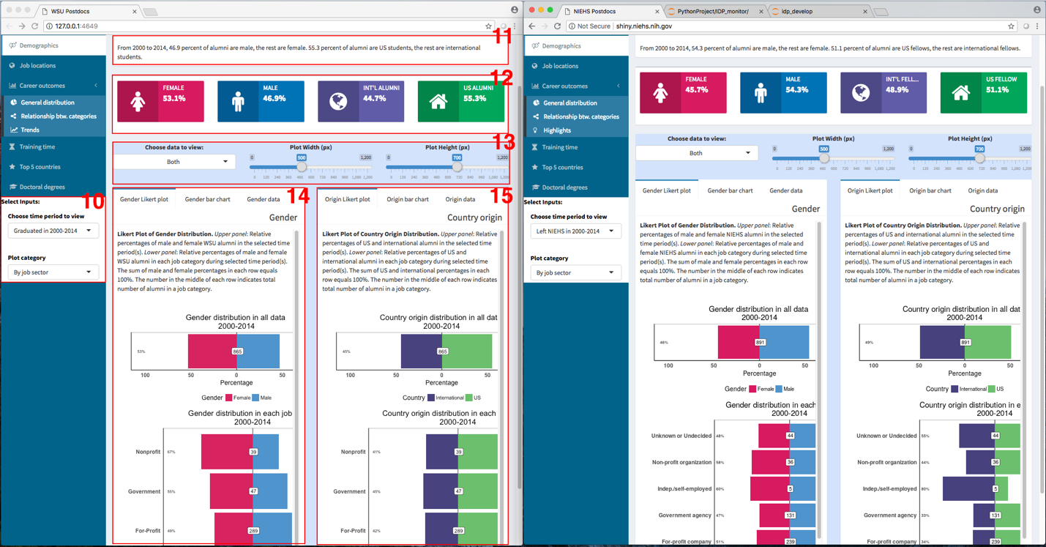

Figure 8. Demographics page

The demographics page visualizes the alumni distribution in different job categories against different gender or country-of-origin background.

1. Visualization selections for demographics data: the input selections for visualizing demographics data. It is a R code section in the user interface program – “ui.R.” It needs to be modified to suit the options of your data visualization (see the code section below).

NIEHS code:

conditionalPanel(

condition = "input.tabs == 'demograph'",

div(HTML("<strong>Select Inputs:</strong>"), style = "color:black;background-color:white;",

# select time period

selectInput("selectDmTp", label = "Choose time period to view", width="230px",

choices = c('Left NIEHS in 2000-2014',

'Left NIEHS in 2000-2004',

'Left NIEHS in 2005-2009',

'Left NIEHS in 2010-2014')),

# select plot style

selectInput("selectDmPc", label = "Plot category", width="230px",

choices = list("By job sector"=1, "By career type"=2,

"By job function"=3), selected = 1)

)

),

WSU code:

conditionalPanel(

condition = "input.tabs == 'demograph'",

div(HTML("<strong>Select Inputs:</strong>"), style = "color:black;background-color:white;",

# select time period

selectInput("selectDmTp", label = "Choose time period to view", width="230px",

choices = c('Graduated in 2000-2014',

'Graduated in 2000-2004',

'Graduated in 2005-2009',

'Graduated in 2010-2014')),

# select plot style

selectInput("selectDmPc", label = "Plot category", width="230px",

choices = list("By job sector"=1, "By career type"=2,

"By job function"=3), selected = 1)

)

),

1. Summary of demographics data: the brief summary of demographics data. It is a R code section in the user interface program – “ui.R.” It needs to be modified to match your data (see the code section below).

NIEHS code:

fluidRow(

box(

title = "ALUMNI DEMOGRAPHICS", width = 12, solidHeader = TRUE,

paste0("From ", minYrs, " to ", maxYrs, ", ", tMalePct, " percent of alumni are male, the rest are female. ",

tCitizenPct, " percent of alumni are US fellows, the rest are international fellows.")

)

),

WSU code:

fluidRow(

box(

title = "ALUMNI DEMOGRAPHICS", width = 12, solidHeader = TRUE,

paste0("From ", minYrs, " to ", maxYrs, ", ", tMalePct, " percent of alumni are male, the rest are female. ",

tCitizenPct, " percent of alumni are US students, the rest are international students.")

)

),

1. Statistics of demographics data: the information box of demographics statistics. It is a R code section in the dashboard server program – “server.R.” It needs to be modified to match your data (see the code section below).

NIEHS code:

# demographics information boxes

output$demoInfoBox<-renderUI({

if (input$selectDmTp == 'Trend') {

gendData = gendYrAll

citiData = citiYrAll

# https://stackoverflow.com/questions/15059076/call-apply-like-function-on-each-row-of-dataframe-with-multiple-arguments-from-e

gendData.m <- melt(gendData, id.vars = "years")

gendData.nm <- gendData.m %>% group_by(years) %>% mutate(Percent=round(value/sum(value),3)*100)

femalePct = paste0(gendData.nm[gendData.nm$variable == "Female",]$Percent,"%")

malePct = paste0(gendData.nm[gendData.nm$variable == "Male",]$Percent,"%")

citiData.m <- melt(citiData, id.vars = "years")

citiData.nm <- citiData.m %>% group_by(years) %>% mutate(Percent=round(value/sum(value),3)*100)

visitPct = paste0(citiData.nm[citiData.nm$variable == "International",]$Percent,"%")

usaPct = paste0(citiData.nm[citiData.nm$variable == "US",]$Percent,"%")

box(

width = 12,

fluidRow(

infoBox("Female change", paste(femalePct, collapse = " -> "), icon = icon("female"), color = "maroon", fill=TRUE, width=3),

infoBox("Male change", paste(malePct, collapse = " -> "), icon = icon("male"), color = "blue", fill=TRUE, width=3),

infoBox("International fellow change", paste(visitPct, collapse = " -> "), icon = icon("globe"), color = "purple", fill=TRUE, width=3),

infoBox("US fellow change", paste(usaPct, collapse = " -> "), icon = icon("home"), color = "green", fill=TRUE, width=3)

)

)

}

else {

if (input$selectDmTp == 'Left NIEHS in 2000-2014') {

gendData = gend4All

citiData = citi4All

}

else {

gendData = subset(gendYrAll, years == timeConvert(input$selectDmTp))

citiData = subset(citiYrAll, years == timeConvert(input$selectDmTp))

}

malePct = as.numeric(gendData[,"Male"] / (gendData[,"Male"] + gendData[,"Female"]))

femalePct = 1 - malePct

visitPct = as.numeric(citiData[,"International"] / (citiData[,"International"] + citiData[,"US"]))

usaPct = 1 - visitPct

box(

width = 12,

fluidRow(

infoBox("Female", paste0(round(femalePct, 3)*100, "%"), icon = icon("female"), color = "maroon", fill=TRUE, width=3),

infoBox("Male", paste0(round(malePct, 3)*100, "%"), icon = icon("male"), color = "blue", fill=TRUE, width=3),

infoBox("Int'l fellow", paste0(round(visitPct, 3)*100, "%"), icon = icon("globe"), color = "purple", fill=TRUE, width=3),

infoBox("US fellow", paste0(round(usaPct, 3)*100, "%"), icon = icon("home"), color = "green", fill=TRUE, width=3)

)

)

}

})

WSU code:

# demographics information boxes

output$demoInfoBox<-renderUI({

if (input$selectDmTp == 'Trend') {

gendData = gendYrAll

citiData = citiYrAll

# https://stackoverflow.com/questions/15059076/call-apply-like-function-on-each-row-of-dataframe-with-multiple-arguments-from-e

gendData.m <- melt(gendData, id.vars = "years")

gendData.nm <- gendData.m %>% group_by(years) %>% mutate(Percent=round(value/sum(value),3)*100)

femalePct = paste0(gendData.nm[gendData.nm$variable == "Female",]$Percent,"%")

malePct = paste0(gendData.nm[gendData.nm$variable == "Male",]$Percent,"%")

citiData.m <- melt(citiData, id.vars = "years")

citiData.nm <- citiData.m %>% group_by(years) %>% mutate(Percent=round(value/sum(value),3)*100)

visitPct = paste0(citiData.nm[citiData.nm$variable == "International",]$Percent,"%")

usaPct = paste0(citiData.nm[citiData.nm$variable == "US",]$Percent,"%")

box(

width = 12,

fluidRow(

infoBox("Female change", paste(femalePct, collapse = " -> "), icon = icon("female"), color = "maroon", fill=TRUE, width=3),

infoBox("Male change", paste(malePct, collapse = " -> "), icon = icon("male"), color = "blue", fill=TRUE, width=3),

infoBox("International alumni change", paste(visitPct, collapse = " -> "), icon = icon("globe"), color = "purple", fill=TRUE, width=3),

infoBox("US alumni change", paste(usaPct, collapse = " -> "), icon = icon("home"), color = "green", fill=TRUE, width=3)

)

)

}

else {

if (input$selectDmTp == 'Graduated in 2000-2014') {

gendData = gend4All

citiData = citi4All

}

else {

gendData = subset(gendYrAll, years == timeConvert(input$selectDmTp))

citiData = subset(citiYrAll, years == timeConvert(input$selectDmTp))

}

malePct = as.numeric(gendData[,"Male"] / (gendData[,"Male"] + gendData[,"Female"]))

femalePct = 1 - malePct

visitPct = as.numeric(citiData[,"International"] / (citiData[,"International"] + citiData[,"US"]))

usaPct = 1 - visitPct

box(

width = 12,

fluidRow(

infoBox("Female", paste0(round(femalePct, 3)*100, "%"), icon = icon("female"), color = "maroon", fill=TRUE, width=3),

infoBox("Male", paste0(round(malePct, 3)*100, "%"), icon = icon("male"), color = "blue", fill=TRUE, width=3),

infoBox("Int'l alumni", paste0(round(visitPct, 3)*100, "%"), icon = icon("globe"), color = "purple", fill=TRUE, width=3),

infoBox("US alumni", paste0(round(usaPct, 3)*100, "%"), icon = icon("home"), color = "green", fill=TRUE, width=3)

)

)

}

})

1. Plot selections for demographics data: the plot selections for visualizing demographics data. It is a R code section in the user interface program – “ui.R.” It doesn’t need to be modified (see the code section below).

NIEHS/WSU code:

div(id = "dmPlot", style="background-color:#d4e3fc;",

fluidRow(

column(4, align="center",

selectInput("selectShowDm", label = "Choose data to view:",

choices = list("Gender only"=1, "Country origin only"=3, "Both"=2), selected = 2)

),

column(4, align="center",

sliderInput("sldWidthDm", "Plot Width (px)", min = 0, max = 1200, value = 500)

),

column(4, align="center",

sliderInput("sldHeightDm", "Plot Height (px)", min = 0, max = 1200, value = 700)

)

),

1. Gender plot of demographics data: the plot for visualizing gender data. It is a R code section in the dashboard server program – “server.R.” It needs to be modified to match your data. The code section is too long to be listed here. It includes 6 code segments:

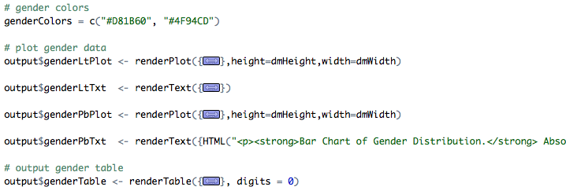

Figure 9. Code section of gender plot

* Gender color definition – genderColors
* Gender likert plot – output$genderLtPlot <- renderPlot
* Gender likert plot text – output$genderLtPlot <- renderText
* Gender bar plot – output$genderPbPlot <- renderPlot
* Gender bar plot text – output$genderPbPlot <- renderText
* Gender data table – output$genderTable <- renderTable

1. Country origin plot of demographics data: the plot for visualizing country origin data. It is a R code section in the dashboard server program – “server.R.” It needs to be modified to match your data. The code section is too long to be listed here. It includes 6 code segments:

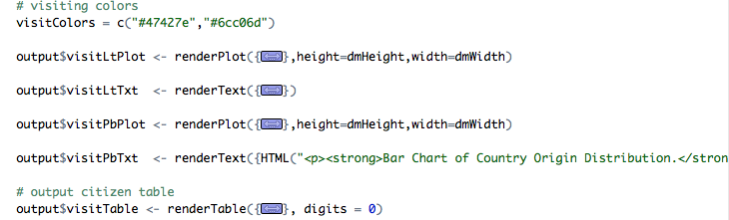

Figure 10. Code section of country origin plot

* Country origin color definition – visitColors
* Country origin likert plot – output$visitLtPlot <- renderPlot
* Country origin likert plot text – output$visitLtPlot <- renderText
* Country origin bar plot – output$visitPbPlot <- renderPlot
* Country origin bar plot text – output$visitPbPlot <- renderText
* Country origin data table – output$visitTable <- renderTable

*Job location page*

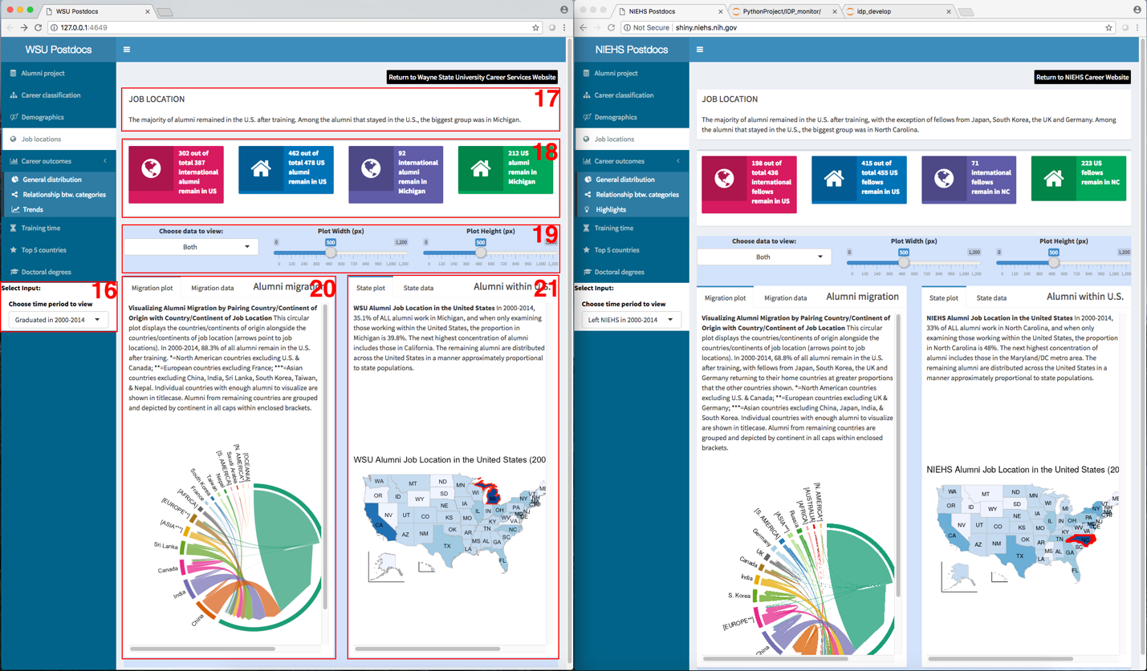

Figure 11. Job location page

The job location page visualizes the alumni job distribution in global migration and in the US states.

1. Visualization selections for job location data: the input selections for visualizing job location data. It is a R code section in the user interface program – “ui.R.” It needs to be modified to suit the options of your data visualization (see the code section below).

NIEHS code:

conditionalPanel(

condition = "input.tabs == 'location'",

div(HTML("<strong>Select Inputs:</strong>"), style = "color:black;background-color:white;",

# select time period

selectInput("selectLcTp", label = "Choose time period to view", width="230px",

choices = c('Left NIEHS in 2000-2014',

'Left NIEHS in 2000-2004',

'Left NIEHS in 2005-2009',

'Left NIEHS in 2010-2014'))

)

),

WSU code:

conditionalPanel(

condition = "input.tabs == 'location'",

div(HTML("<strong>Select Inputs:</strong>"), style = "color:black;background-color:white;",

# select time period

selectInput("selectLcTp", label = "Choose time period to view", width="230px",

choices = c('Graduated in 2000-2014',

'Graduated in 2000-2004',

'Graduated in 2005-2009',

'Graduated in 2010-2014'))

)

),

1. Summary of job location data: the brief summary of job location data. It is a R code section in the user interface program – “ui.R.” It needs to be modified to match your data (see the code section below).

NIEHS code:

fluidRow(

box(

title = "JOB LOCATION", width = 12, solidHeader = TRUE,

"The majority of alumni remained in the U.S. after training, with the exception

of fellows from Japan, South Korea, the UK and Germany. Among the alumni

that stayed in the U.S., the biggest group was in North Carolina."

)

),

WSU code:

fluidRow(

box(

title = "JOB LOCATION", width = 12, solidHeader = TRUE,

"The majority of alumni remained in the U.S. after training. Among the alumni

that stayed in the U.S., the biggest group was in Michigan."

)

),

1. Statistics of job location data: the information box of job location statistics. It is a R code section in the dashboard server program – “server.R.” It needs to be modified to match your data (see the code section below).

NIEHS code:

# location information boxes

output$locaInfoBox<-renderUI({

if (input$selectLcTp == 'Left NIEHS in 2000-2014') {

locData = dataGroup

}

else {

locData = dataGroup[dataGroup$years == timeConvert(input$selectLcTp), ]

}

visTT = nrow(locData[locData$citizenship == 'International',])

nvsTT = nrow(locData[locData$citizenship == 'US',])

visUS = nrow(locData[locData$citizenship == 'International' & locData$job_country == 'United States',])

nvsUS = nrow(locData[locData$citizenship == 'US' & locData$job_country == 'United States',])

visNC = nrow(locData[locData$citizenship == 'International' & locData$job_state == 'North Carolina',])

nvsNC = nrow(locData[locData$citizenship == 'US' & locData$job_state == 'North Carolina',])

box(

width = 12,

fluidRow(

infoBox("", value = tags$p(paste(visUS, "out of total", visTT, "international fellows remain in US"), style = "font-size: 75%;"), icon = icon("globe"), color = "maroon", fill=TRUE, width=3),

infoBox("", value = tags$p(paste(nvsUS, "out of total", nvsTT, "US fellows remain in US"), style = "font-size: 75%;"), icon = icon("home"), color = "blue", fill=TRUE, width=3),

infoBox("", value = tags$p(paste(visNC, "international fellows remain in NC"), style = "font-size: 75%;"), icon = icon("globe"), color = "purple", fill=TRUE, width=3),

infoBox("", value = tags$p(paste(nvsNC, "US fellows remain in NC"), style = "font-size: 75%;"), icon = icon("home"), color = "green", fill=TRUE, width=3)

)

)

})

WSU code:

# location information boxes

output$locaInfoBox<-renderUI({

if (input$selectLcTp == 'Graduated in 2000-2014') {

locData = dataGroup

}

else {

locData = dataGroup[dataGroup$years == timeConvert(input$selectLcTp), ]

}

visTT = nrow(locData[locData$citizenship == 'International',])

nvsTT = nrow(locData[locData$citizenship == 'US',])

visUS = nrow(locData[locData$citizenship == 'International' & locData$job_country == 'United States',])

nvsUS = nrow(locData[locData$citizenship == 'US' & locData$job_country == 'United States',])

visST = nrow(locData[locData$citizenship == 'International' & locData$job_state == 'Michigan',])

nvsST = nrow(locData[locData$citizenship == 'US' & locData$job_state == 'Michigan',])

box(

width = 12,

fluidRow(

infoBox("", value = tags$p(paste(visUS, "out of total", visTT, "international alumni remain in US"), style = "font-size: 75%;"), icon = icon("globe"), color = "maroon", fill=TRUE, width=3),

infoBox("", value = tags$p(paste(nvsUS, "out of total", nvsTT, "US alumni remain in US"), style = "font-size: 75%;"), icon = icon("home"), color = "blue", fill=TRUE, width=3),

infoBox("", value = tags$p(paste(visST, "international alumni remain in Michigan"), style = "font-size: 75%;"), icon = icon("globe"), color = "purple", fill=TRUE, width=3),

infoBox("", value = tags$p(paste(nvsST, "US alumni remain in Michigan"), style = "font-size: 75%;"), icon = icon("home"), color = "green", fill=TRUE, width=3)

)

)

})

1. Plot selections for job location data: the plot selections for visualizing job location data. It is a R code section in the user interface program – “ui.R.” It doesn’t need to be modified (see the code section below).

NIEHS/WSU code:

div(id = "lcPlot", style="background-color:#d4e3fc;",

fluidRow(

column(4, align="center",

selectInput("selectShowLc", label = "Choose data to view:",

choices = list("Migration only"=1, "State location only"=3, "Both"=2), selected = 2)

),

column(4, align="center",

sliderInput("sldWidthLc", "Plot Width (px)", min = 0, max = 1200, value = 500)

),

column(4, align="center",

sliderInput("sldHeightLc", "Plot Height (px)", min = 0, max = 1200, value = 700)

)

),

1. Migration plot of job location data: the plot for visualizing alumni migration data. It is a R code section in the dashboard server program – “server.R.” It needs to be modified to match your data. The code section is too long to be listed here. It includes 3 code segments:

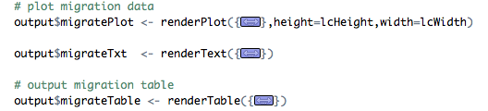

Figure 12. Code section of migration plot of job location data

* Migration plot – output$migratePlot <- renderPlot
* Migration text – output$migrateTxt <- renderText
* Migration data table – output$migrateTable <- renderTable

1. State plot of job location data: the plot for visualizing alumni job location data in US states. It is a R code section in the dashboard server program – “server.R.” It needs to be modified to match your data. The code section is too long to be listed here. It includes 3 code segments:

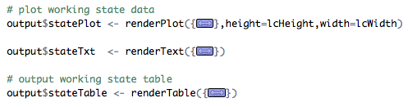

Figure 13. Code section of state plot of job location

* State plot – output$statePlot <- renderPlot
* State text – output$stateTxt <- renderText
* State data table – output$stateTable <- renderTable

*Career outcomes – general distribution page*

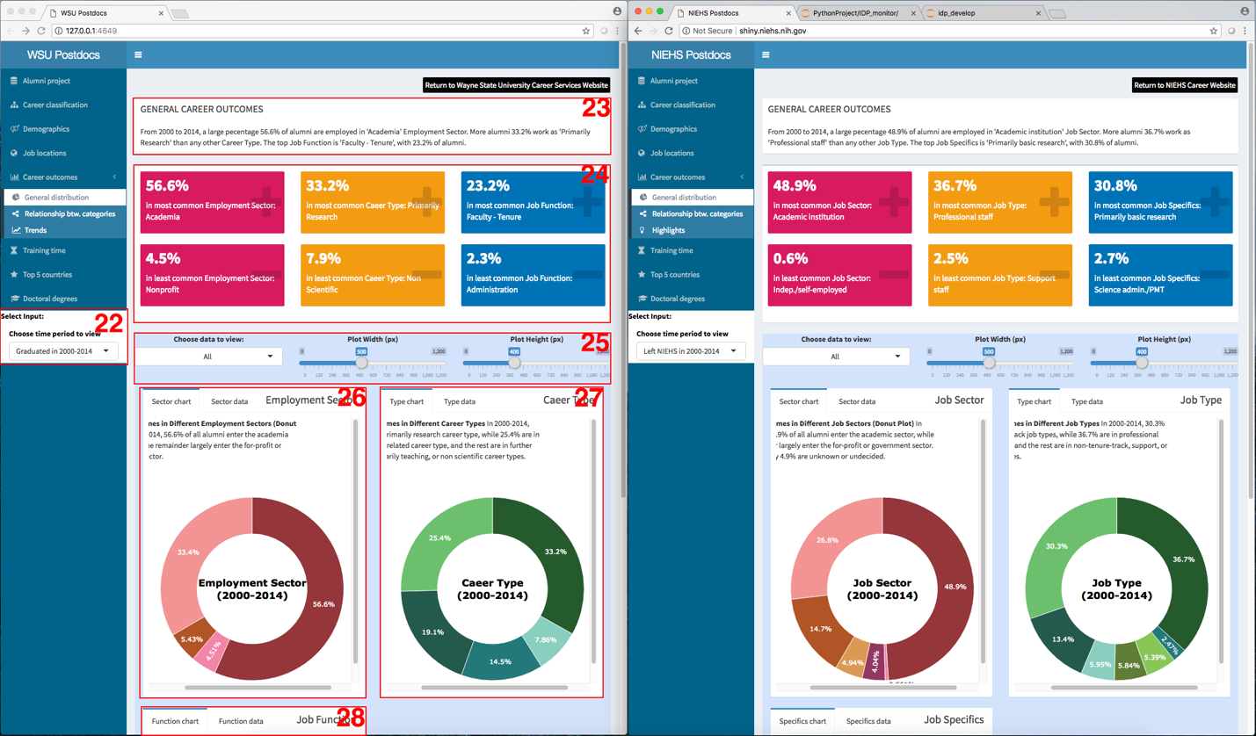

Figure 14. Job location page

The general distribution page visualizes the alumni job distribution in the 3 career outcome categories .

1. Visualization selections for general distribution data: the input selections for visualizing general distribution of career outcome data. It is a R code section in the user interface program – “ui.R.” It needs to be modified to suit the options of your data visualization (see the code section below).

NIEHS code:

conditionalPanel(

condition = "input.tabs == 'general'",

div(HTML("<strong>Select Inputs:</strong>"), style = "color:black;background-color:white;",

# select time period

selectInput("selectGnrTp", label = "Choose time period to view", width="230px",

choices = c('Left NIEHS in 2000-2014',

'Left NIEHS in 2000-2004',

'Left NIEHS in 2005-2009',

'Left NIEHS in 2010-2014'))

)

),

WSU code:

conditionalPanel(

condition = "input.tabs == 'general'",

div(HTML("<strong>Select Inputs:</strong>"), style = "color:black;background-color:white;",

# select time period

selectInput("selectGnrTp", label = "Choose time period to view", width="230px",

choices = c('Graduated in 2000-2014',

'Graduated in 2000-2004',

'Graduated in 2005-2009',

'Graduated in 2010-2014'))

)

),

1. Summary of general career distribution data: the brief summary of general career distribution data. It is a R code section in the user interface program – “ui.R.” It needs to be modified to match your data (see the code section below).

NIEHS code:

fluidRow(

box(title = "GENERAL CAREER OUTCOMES", width = 12, solidHeader = TRUE,

paste0("From 2000 to 2014, a large pecentage ", max(tGnrSectorPct), "% of alumni are employed in '", names(which(tGnrSectorPct==max(tGnrSectorPct))), "' Job Sector. ",

"More alumni ", max(tGnrTypePct), "% work as '", names(which(tGnrTypePct==max(tGnrTypePct))), "' than any other Job Type. ",

"The top Job Specifics is '", names(which(tGnrSpecPct==max(tGnrSpecPct))), "', with ", max(tGnrSpecPct), "% of alumni.")

)

),

WSU code:

fluidRow(

box(title = "GENERAL CAREER OUTCOMES", width = 12, solidHeader = TRUE,

paste0("From 2000 to 2014, a large pecentage ", max(tGnrSectorPct), "% of alumni are employed in '", names(which(tGnrSectorPct==max(tGnrSectorPct))), "' Employment Sector. ",

"More alumni ", max(tGnrTypePct), "% work as '", names(which(tGnrTypePct==max(tGnrTypePct))), "' than any other Career Type. ",

"The top Job Function is '", names(which(tGnrFuncPct==max(tGnrFuncPct))), "', with ", max(tGnrFuncPct), "% of alumni.")

)

),

1. Statistics of general career distribution data: the information box of general career distribution statistics. It is a R code section in the dashboard server program – “server.R.” It needs to be modified to match your data (see the code section below).

NIEHS code:

# general career information boxes

output$genrInfoBox<-renderUI({

if (input$selectGnrTp %in% c('Left NIEHS in 2000-2014', 'Trend')) {

itmdData = dataGroup

}

else {

itmdData = subset(dataGroup, years == timeConvert(input$selectGnrTp))

}

gnrCount = nrow(itmdData)

cGnrSector = table(itmdData[,"job_sector"])

cGnrSectorPct = round(cGnrSector / gnrCount, 3) * 100

cGnrType = table(itmdData[,"job_type"])

cGnrTypePct = round(cGnrType / gnrCount, 3) * 100

cGnrSpecifics = table(itmdData[,"specifics"])

cGnrSpecPct = round(cGnrSpecifics / gnrCount, 3) * 100

box(

width = 12,

fluidRow(

valueBox(subtitle = paste0("in most common Job Sector: ", names(which(cGnrSectorPct==max(cGnrSectorPct)))), value = tags$p(paste0(max(cGnrSectorPct), "%"), style = "font-size: 75%;"), icon = icon("plus"), color = "maroon", width=4),

valueBox(subtitle = paste0("in most common Job Type: ", names(which(cGnrTypePct==max(cGnrTypePct)))), value = tags$p(paste0(max(cGnrTypePct), "%"), style = "font-size: 75%;"), icon = icon("plus"), color = "yellow", width=4),

valueBox(subtitle = paste0("in most common Job Specifics: ", names(which(cGnrSpecPct==max(cGnrSpecPct)))), value = tags$p(paste0(max(cGnrSpecPct), "%"), style = "font-size: 75%;"), icon = icon("plus"), color = "blue", width=4)

),

fluidRow(

valueBox(subtitle = paste0("in least common Job Sector: ", names(which(cGnrSectorPct==min(cGnrSectorPct)))), value = tags$p(paste0(min(cGnrSectorPct), "%"), style = "font-size: 75%;"), icon = icon("minus"), color = "maroon", width=4),

valueBox(subtitle = paste0("in least common Job Type: ", names(which(cGnrTypePct==min(cGnrTypePct)))), value = tags$p(paste0(min(cGnrTypePct), "%"), style = "font-size: 75%;"), icon = icon("minus"), color = "yellow", width=4),

valueBox(subtitle = paste0("in least common Job Specifics: ", names(which(cGnrSpecPct==min(cGnrSpecPct)))), value = tags$p(paste0(min(cGnrSpecPct), "%"), style = "font-size: 75%;"), icon = icon("minus"), color = "blue", width=4)

)

)

})

WSU code:

# general career information boxes

output$genrInfoBox<-renderUI({

if (input$selectGnrTp %in% c('Graduated in 2000-2014', 'Trend')) {

itmdData = dataGroup

}

else {

itmdData = subset(dataGroup, years == timeConvert(input$selectGnrTp))

}

gnrCount = nrow(itmdData)

cGnrSector = table(itmdData[,"job_sector"])

cGnrSectorPct = round(cGnrSector / gnrCount, 3) * 100

cGnrType = table(itmdData[,"career_type"])

cGnrTypePct = round(cGnrType / gnrCount, 3) * 100

cGnrFunction = table(itmdData[,"job_function"])

cGnrFuncPct = round(cGnrFunction / gnrCount, 3) * 100

box(

width = 12,

fluidRow(

valueBox(subtitle = paste0("in most common Employment Sector: ", names(which(cGnrSectorPct==max(cGnrSectorPct)))), value = tags$p(paste0(max(cGnrSectorPct), "%"), style = "font-size: 75%;"), icon = icon("plus"), color = "maroon", width=4),

valueBox(subtitle = paste0("in most common Caeer Type: ", names(which(cGnrTypePct==max(cGnrTypePct)))), value = tags$p(paste0(max(cGnrTypePct), "%"), style = "font-size: 75%;"), icon = icon("plus"), color = "yellow", width=4),

valueBox(subtitle = paste0("in most common Job Function: ", names(which(cGnrFuncPct==max(cGnrFuncPct)))), value = tags$p(paste0(max(cGnrFuncPct), "%"), style = "font-size: 75%;"), icon = icon("plus"), color = "blue", width=4)

),

fluidRow(

valueBox(subtitle = paste0("in least common Employment Sector: ", names(which(cGnrSectorPct==min(cGnrSectorPct)))), value = tags$p(paste0(min(cGnrSectorPct), "%"), style = "font-size: 75%;"), icon = icon("minus"), color = "maroon", width=4),

valueBox(subtitle = paste0("in least common Caeer Type: ", names(which(cGnrTypePct==min(cGnrTypePct)))), value = tags$p(paste0(min(cGnrTypePct), "%"), style = "font-size: 75%;"), icon = icon("minus"), color = "yellow", width=4),

valueBox(subtitle = paste0("in least common Job Function: ", names(which(cGnrFuncPct==min(cGnrFuncPct)))), value = tags$p(paste0(min(cGnrFuncPct), "%"), style = "font-size: 75%;"), icon = icon("minus"), color = "blue", width=4)

)

)

})

1. Plot selections for general career distribution data: the plot selections for visualizing general career distribution data. It is a R code section in the user interface program – “ui.R.” It has to be modified to match your career outcome data (see the code section below).

NIEHS code:

div(id = "gnrPlot", style="background-color:#d4e3fc;",

fluidRow(

column(4, align="center",

selectInput("selectShowGnr", label = "Choose data to view:",

choices = list("All"=1, "Job Sector"=2, "Job Type"=3, "Job Specifics"=4), selected = 1)

),

column(4, align="center",

sliderInput("sldWidthGnr", "Plot Width (px)", min = 0, max = 1200, value = 500)

),

column(4, align="center",

sliderInput("sldHeightGnr", "Plot Height (px)", min = 0, max = 1200, value = 400)

)

),

WSU code:

div(id = "gnrPlot", style="background-color:#d4e3fc;",

fluidRow(

column(4, align="center",

selectInput("selectShowGnr", label = "Choose data to view:",

choices = list("All"=1, "Employment Sector"=2, "Career Type"=3, "Job Function"=4), selected = 1)

),

column(4, align="center",

sliderInput("sldWidthGnr", "Plot Width (px)", min = 0, max = 1200, value = 500)

),

column(4, align="center",

sliderInput("sldHeightGnr", "Plot Height (px)", min = 0, max = 1200, value = 400)

)

),

1. Employment/job sector plot of general career distribution data: the plot for visualizing alumni distribution in the career taxonomy tier 1 – employment sector (WSU version) or job sector (NIEHS version). It is a R code section in the dashboard server program – “server.R.” It needs to be modified to match your data. The code section is too long to be listed here. It includes 3 code segments:

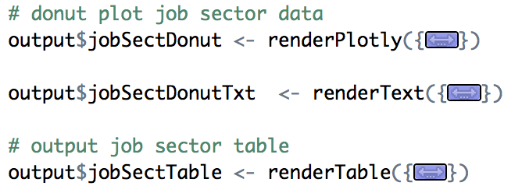

Figure 15. Code section of job sector plot of general career distribution data

* Job sector donut plot – output$jobSectDonut <- renderPlotly
* Job sector donut plot text – output$ jobSectDonutTxt <- renderText
* Job sector data table – output$ jobSectTable <- renderTable

1. Career/job type plot of general career distribution data: the plot for visualizing alumni distribution in the career taxonomy tier 2 – career type (WSU version) or job type (NIEHS version). It is a R code section in the dashboard server program – “server.R.” It needs to be modified to match your data. The code section is too long to be listed here. It includes 3 code segments:

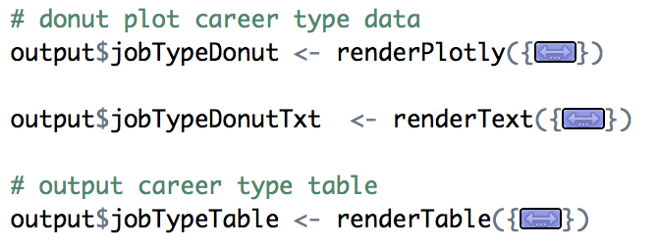

Figure 16. Code section of job type plot of general career distribution data

* Job type donut plot – output$jobTypeDonut <- renderPlotly
* Job type donut plot text – output$ jobTypeDonutTxt <- renderText
* Job type data table – output$ jobTypeTable <- renderTable

1. Job function/job specifics plot of general career distribution data: the plot for visualizing alumni distribution in the career taxonomy tier 3 – job function (WSU version) or job specifics (NIEHS version). It is a R code section in the dashboard server program – “server.R.” It needs to be modified to match your data. The code section is too long to be listed here. It includes 3 code segments:

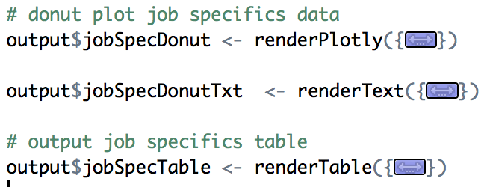

Figure 17. Code section of job specifics plot of general career distribution data

* Job specifics donut plot – output$jobSpecDonut <- renderPlotly
* Job specifics donut plot text – output$ jobSpecDonutTxt <- renderText
* Job specifics data table – output$ jobSpecTable <- renderTable

*Career outcomes – relationship between job categories page*

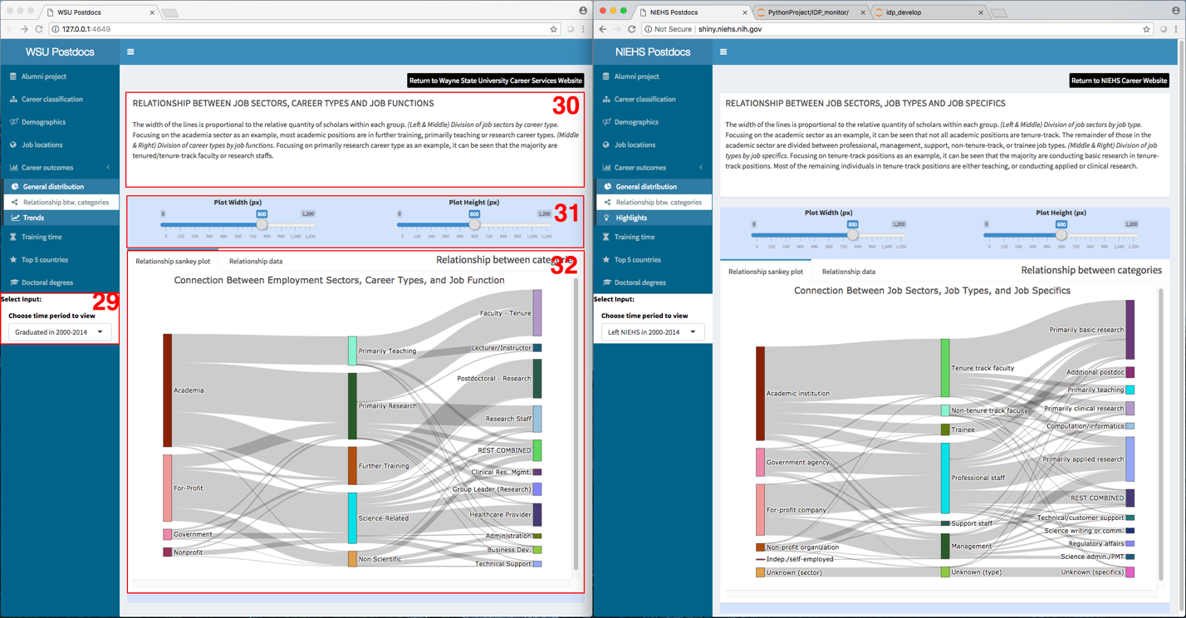

Figure 18. Relationship between job categories

1. Visualization selections for relationship between job categories: the input selections for visualizing relationship between job categories. It is a R code section in the user interface program – “ui.R.” It needs to be modified to suit the options of your data visualization (see the code section below).

NIEHS code:

conditionalPanel(

condition = "input.tabs == 'relation'",

div(HTML("<strong>Select Inputs:</strong>"), style = "color:black;background-color:white;",

# select time period

selectInput("selectRlnTp", label = "Choose time period to view", width="230px",

choices = c('Left NIEHS in 2000-2014',

'Left NIEHS in 2000-2004',

'Left NIEHS in 2005-2009',

'Left NIEHS in 2010-2014'))

)

),

WSU code:

conditionalPanel(

condition = "input.tabs == 'relation'",

div(HTML("<strong>Select Inputs:</strong>"), style = "color:black;background-color:white;",

# select time period

selectInput("selectRlnTp", label = "Choose time period to view", width="230px",

choices = c('Graduated in 2000-2014',

'Graduated in 2000-2004',

'Graduated in 2005-2009',

'Graduated in 2010-2014'))

)

),

1. Summary of relationship between job categories: the brief summary of relationship between job categories. It is a R code section in the user interface program – “ui.R.” It needs to be modified to match your data (see the code section below).

NIEHS code:

fluidRow(

box(title = "RELATIONSHIP BETWEEN JOB SECTORS, JOB TYPES AND JOB SPECIFICS", width = 12, solidHeader = TRUE,

HTML("The width of the lines is proportional to the relative quantity of scholars within each group.

<i>(Left & Middle) Division of job sectors by job type.</i> Focusing on the academic sector as an example, it can be seen that not all academic positions are tenure-track. The remainder of those in the academic sector are divided between professional, management, support, non-tenure-track, or trainee job types.

<i>(Middle & Right) Division of job types by job specifics.</i> Focusing on tenure-track positions as an example, it can be seen that the majority are conducting basic research in tenure-track positions. Most of the remaining individuals in tenure-track positions are either teaching, or conducting applied or clinical research.</p><p>&nbsp;</p>")

)

),

WSU code:

fluidRow(

box(title = "RELATIONSHIP BETWEEN EMPLOYMENT SECTORS, CAREER TYPES AND JOB FUNCTIONS", width = 12, solidHeader = TRUE,

HTML("The width of the lines is proportional to the relative quantity of scholars within each group.

<i>(Left & Middle) Division of employment sectors by career type.</i> Focusing on the academia sector as an example, most academic positions are in further training, primarily teaching or research career types.

<i>(Middle & Right) Division of career types by job functions.</i> Focusing on primarily research career type as an example, it can be seen that the majority are tenured/tenure-track faculty or research staffs.</p><p>&nbsp;</p>")

)

),

1. Plot selections for relationship between job categories: the plot selections for visualizing relationship between job categories. It is a R code section in the user interface program – “ui.R.” No modification is needed (see the code section below).

NIEHS/WSU code:

div(id = "rlnPlot", style="background-color:#d4e3fc;",

fluidRow(

column(6, align="center",

sliderInput("sldWidthRln", "Plot Width (px)", min = 0, max = 1200, value = 800)

),

column(6, align="center",

sliderInput("sldHeightRln", "Plot Height (px)", min = 0, max = 1200, value = 600)

)

),

1. Sankey plot of relationship between job categories: the plot for visualizing relationship between job categories. It is a R code section in the dashboard server program – “server.R.” It needs to be modified to match your data. The code section is too long to be listed here. It includes 2 code segments:

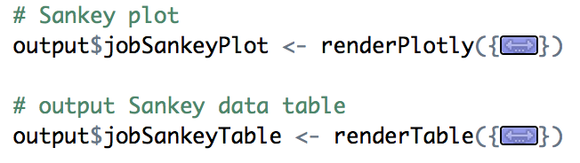

Figure 19. Code section of relationship between job categories

* Job category relationship plot – output$jobSankeyDonut <- renderPlotly
* Job category relationship data table – output$ jobSankeyTable <- renderTable

*Career outcomes – trend page (WSU) vs. highlight page (NIEHS)*

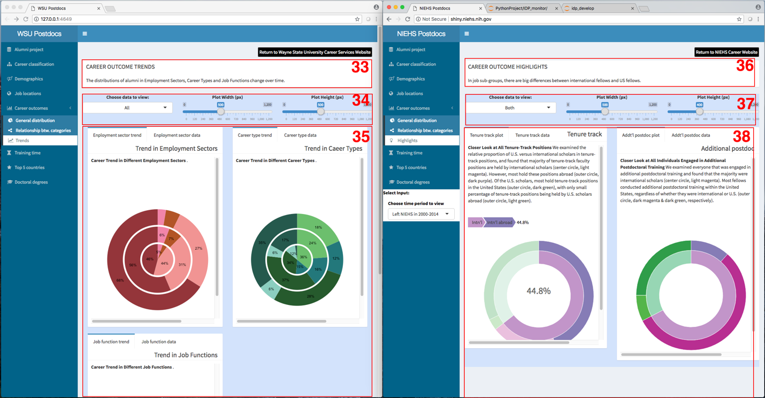

Figure 20. *Trend page (WSU) vs. highlight page (NIEHS)*

In this career outcome visualization page, we show the different plot approaches for NIEHS data and WSU data. For the NIEHS data, we highlight the differences between US fellows and international visiting fellows in tenure track positions and additional postdoctoral training positions. For the WSU data, we show the trend changes in employment sectors, career types, and job functions from 2000-2004, 2005-2009, to 2010-2014. It is an example of developing new code sections for new data, than adapting existing code sections for similar data showed in previous visualization pages.

1. Summary of career outcome trends (WSU): the brief description of career outcome trends for WSU data. It is a new R code section in the user interface program – “ui.R” (see the code section below).

fluidRow(

box(title = "CAREER OUTCOME TRENDS", width = 12, solidHeader = TRUE,

"The distributions of alumni in Employment Sectors, Career Types and Job Functions change over time.")

),

1. Plot selection for career outcome trends(WSU): the plot selections for visualizing career outcome trends of WSU data. It is a new R code section in the user interface program – “ui.R” (see the code section below).

div(id = "trndPlot", style="background-color:#d4e3fc;",

fluidRow(

column(4, align="center",

selectInput("selectShowTrnd", label = "Choose data to view:",

choices = list("All"=1, "Employment Sector"=2, "Career Type"=3, "Job Function"=4), selected=1)

),

column(4, align="center",

sliderInput("sldWidthTrnd", "Plot Width (px)", min = 0, max = 1200, value = 500)

),

column(4, align="center",

sliderInput("sldHeightTrnd", "Plot Height (px)", min = 0, max = 1200, value = 500)

)

),

1. Plots of career outcome trends (WSU): the plots for career outcome trends of WSU data. They are three new R code sections in the dashboard server program – “server.R.” These code sections are too long to be listed here.

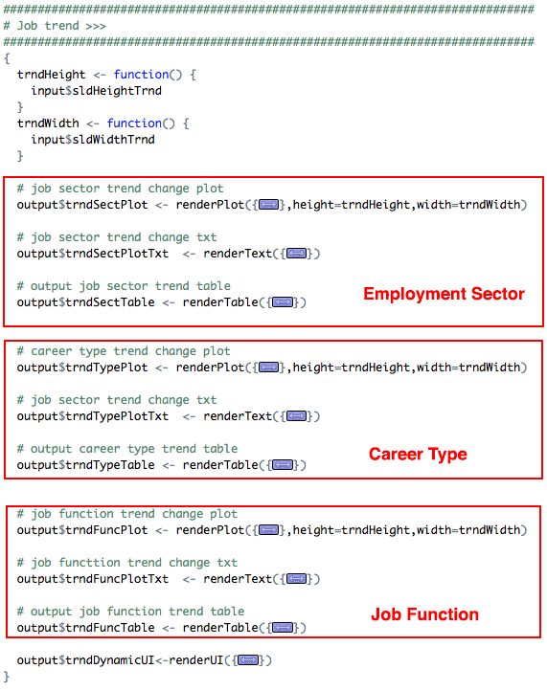

Figure 21. Code sections of career outcome trends for WSU data

* Career outcome trend in employment sector
  + Plot – output$trndSectPlot <- renderPlot
  + Plot text – output$trndSectPlotTxt <- renderText
  + Data table – output$trndSectTable <- renderTable
* Career outcome trend in career type
  + Plot – output$trndTypePlot <- renderPlot
  + Plot text – output$trndTypePlotTxt <- renderText
  + Data table – output$trndTypeTable <- renderTable
* Career outcome trend in job function
  + Plot – output$trndFuncPlot <- renderPlot
  + Plot text – output$trndFuncPlotTxt <- renderText
  + Data table – output$trndFuncTable <- renderTable
* Visualization layout of career outcome trends – output$trndDynamicUI <- renderUI

1. Summary of career outcome highlights (NIEHS): the brief description of career outcome highlights for NIEHS data. It is a R code section in the user interface program – “ui.R” (see the code section below).

fluidRow(

box(title = "CAREER OUTCOME HIGHLIGHTS", width = 12, solidHeader = TRUE,

"In job sub-groups, there are big differences between international fellows and US fellows.")

),

1. Plot selection for career outcome highlights(NIHES): the plot selections for visualizing career outcome highlights of NIEHS data. It is a R code section in the user interface program – “ui.R” (see the code section below).

div(id = "hlPlot", style="background-color:#d4e3fc;",

fluidRow(

column(4, align="center",

selectInput("selectShowHl", label = "Choose data to view:",

choices = list("Tenure track"=1, "Additional postdoc"=3, "Both"=2), selected = 2)

),

column(4, align="center",

sliderInput("sldWidthHl", "Plot Width (px)", min = 0, max = 1200, value = 500)

),

column(4, align="center",

sliderInput("sldHeightHl", "Plot Height (px)", min = 0, max = 1200, value = 400)

)

),

1. Plots of career outcome highlights (NIEHS): the plot for career outcome highlights of NIEHS data. They are two R code sections in the dashboard server program – “server.R.” These code sections are too long to be listed here.

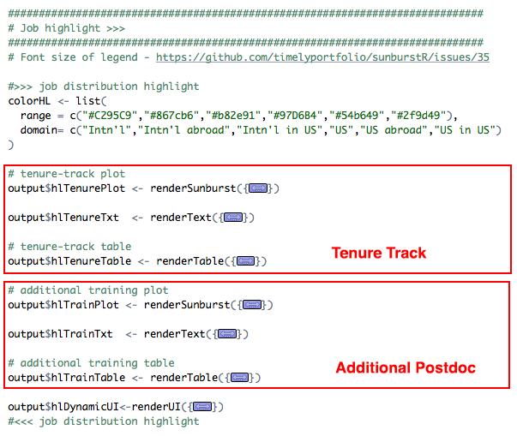

Figure 22. Code sections of career outcome highlights for NIEHS data

* Career outcome trend in employment sector
  + Plot – output$hlTenurePlot <- renderSunburst
  + Plot text – output$hlTenureTxt <- renderText
  + Data table – output$hlTenureTable <- renderTable
* Career outcome highlight in additional training
  + Plot – output$hlTrainPlot <- renderSunburst
  + Plot text – output$hlTrainTxt <- renderText
  + Data table – output$hlTrainTable <- renderTable
* Visualization layout of career outcome highlights – output$hlDynamicUI <- renderUI

*Training time page*

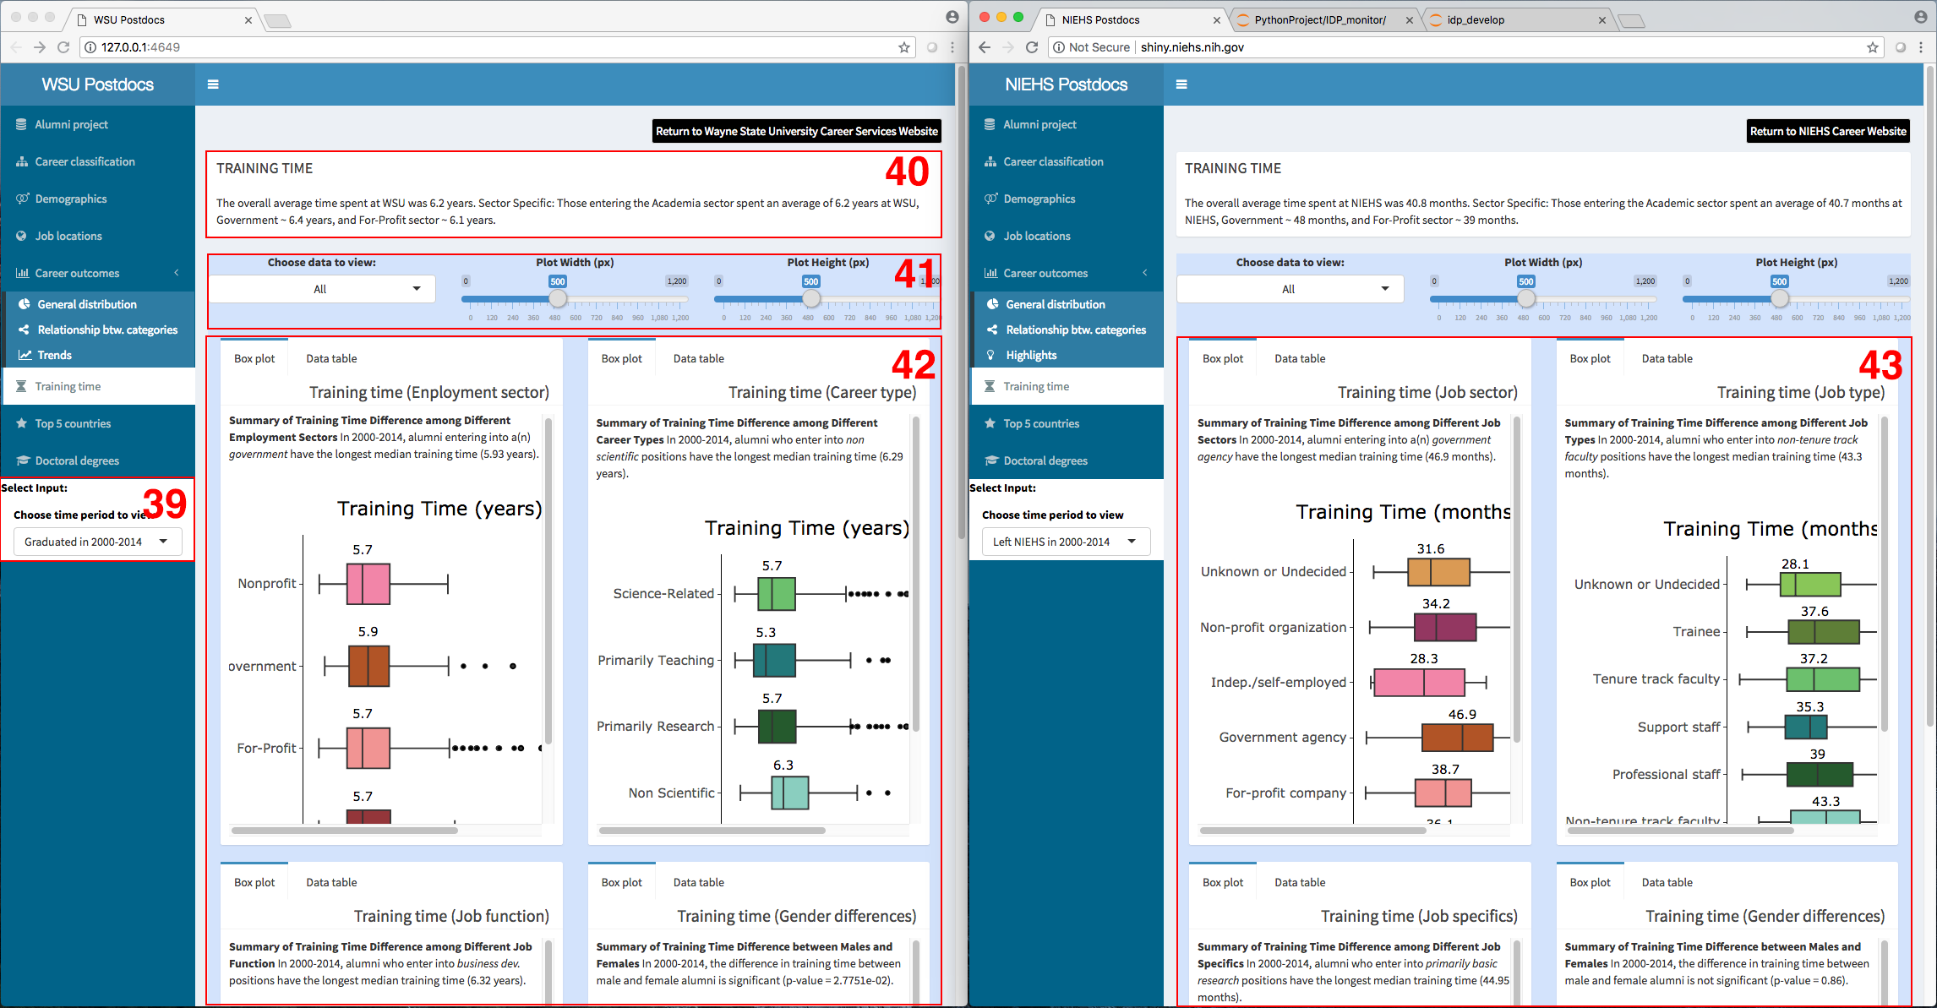

Figure 23. *Training time page*

The training time pages are very similar for WSU data and NIEHS data. The only differences are:

* NIEHS has training time in months while WSU has training time in years.
* NIEHS has training time plots for job sector, job type, job specifics, gender. WSU has training time plots for employment sector, career type, job function, gender, citizenship, and funding status.

1. Visualization selections for training time data: the input selections for visualizing training time. It is a R code section in the user interface program – “ui.R.” It needs to be modified to suit the options of your data visualization (see the code section below).

NIEHS code:

conditionalPanel(

condition = "input.tabs == 'relation'",

div(HTML("<strong>Select Inputs:</strong>"), style = "color:black;background-color:white;",

# select time period

selectInput("selectTmTp", label = "Choose time period to view", width="230px",

choices = c('Left NIEHS in 2000-2014',

'Left NIEHS in 2000-2004',

'Left NIEHS in 2005-2009',

'Left NIEHS in 2010-2014'))

)

),

WSU code:

conditionalPanel(

condition = "input.tabs == 'relation'",

div(HTML("<strong>Select Inputs:</strong>"), style = "color:black;background-color:white;",

# select time period

selectInput("selectTmTp", label = "Choose time period to view", width="230px",

choices = c('Graduated in 2000-2014',

'Graduated in 2000-2004',

'Graduated in 2005-2009',

'Graduated in 2010-2014'))

)

),

1. Summary of training time: the brief description of training time data. It is a R code section in the user interface program – “ui.R.” It needs to be modified to suit the options of your data visualization (see the code section below).

NIEHS code:

fluidRow(

box(title = "TRAINING TIME", width = 12, solidHeader = TRUE,

paste0("The overall average time spent at NIEHS was ", cntAvgTime,

" months. Sector Specific: Those entering the Academic sector spent an average of ", cntAcdTime,

" months at NIEHS, Government ~ ", cntGvnTime, " months, and For-Profit sector ~ ", cntPrfTime, " months.")

)

),

WSU code:

fluidRow(

box(title = "TRAINING TIME", width = 12, solidHeader = TRUE,

paste0("The overall average time spent at WSU was ", cntAvgTime,

" years. Sector Specific: Those entering the Academia sector spent an average of ", cntAcdTime,

" years at WSU, Government ~ ", cntGvnTime, " years, and For-Profit sector ~ ", cntPrfTime, " years.")

)

),

1. Plot selection for training time: the plot selections for visualizing training time data. It is a new R code section in the user interface program – “ui.R.” It needs to be modified to suit the options of your data visualization (see the code section below).

NIEHS code:

div(id = "tmPlot", style="background-color:#d4e3fc;",

fluidRow(

column(4, align="center",

selectInput("selectShowTm", label = "Choose data to view:",

choices = list("All"=1, "Job Sector"=2, "Job Type"=3, "Job Specifics"=4, "Gender"=5), selected = 1)

),

column(4, align="center",

sliderInput("sldWidthTm", "Plot Width (px)", min = 0, max = 1200, value = 500)

),

column(4, align="center",

sliderInput("sldHeightTm", "Plot Height (px)", min = 0, max = 1200, value = 500)

)

),

WSU code:

div(id = "tmPlot", style="background-color:#d4e3fc;",

fluidRow(

column(4, align="center",

selectInput("selectShowTm", label = "Choose data to view:",

choices = list("All"=1, "Employment Sector"=2, "Career Type"=3, "Job Function"=4, "Gender"=5, "Citizen"=6, "Funding"=7), selected = 1)

),

column(4, align="center",

sliderInput("sldWidthTm", "Plot Width (px)", min = 0, max = 1200, value = 500)

),

column(4, align="center",

sliderInput("sldHeightTm", "Plot Height (px)", min = 0, max = 1200, value = 500)

)

),

1. Plots of training time (WSU): the plot for training time of WSU data. They are six R code sections in the dashboard server program – “server.R.” These code sections are too long to be listed here.

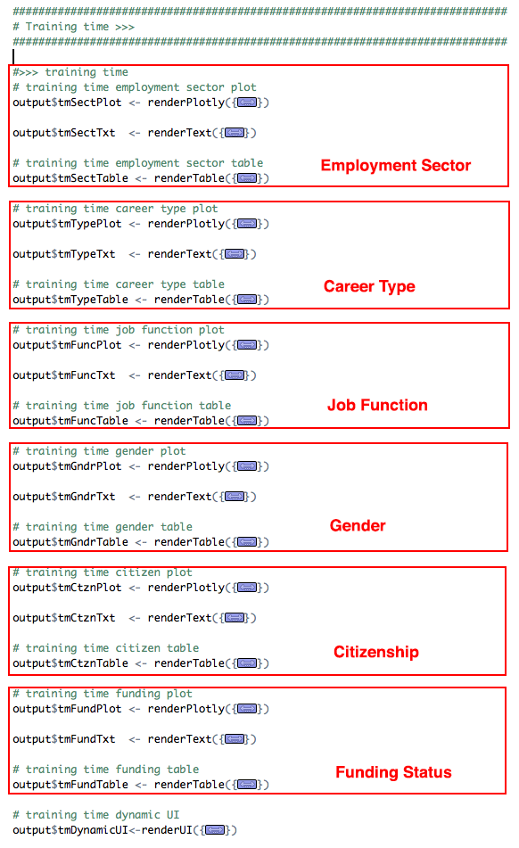

Figure 24. Code sections of training time for WSU data

* Training time in employment sector
  + Plot – output$tmSectPlot <- renderPlotly
  + Plot text – output$tmSectTxt <- renderText
  + Data table – output$tmSectTable <- renderTable
* Training time in career type
  + Plot – output$tmTypePlot <- renderPlotly
  + Plot text – output$tmTypeTxt <- renderText
  + Data table – output$tmTypeTable <- renderTable
* Training time in job function
  + Plot – output$tmFuncPlot <- renderPlotly
  + Plot text – output$tmFuncTxt <- renderText
  + Data table – output$tmFuncTable <- renderTable
* Training time in gender
  + Plot – output$tmGndrPlot <- renderPlotly
  + Plot text – output$tmGndrTxt <- renderText
  + Data table – output$tmGndrTable <- renderTable
* Training time in citizenship
  + Plot – output$tmCtznPlot <- renderPlotly
  + Plot text – output$tmCtznTxt <- renderText
  + Data table – output$tmCtznTable <- renderTable
* Training time in funding status
  + Plot – output$tmFundPlot <- renderPlotly
  + Plot text – output$tmFundTxt <- renderText
  + Data table – output$tmFundTable <- renderTable
* Visualization layout of training time – output$tmDynamicUI <- renderUI

1. Plots of training time (NIEHS): the plot for training time of NIEHS data. They are four R code sections in the dashboard server program – “server.R.” These code sections are too long to be listed here.

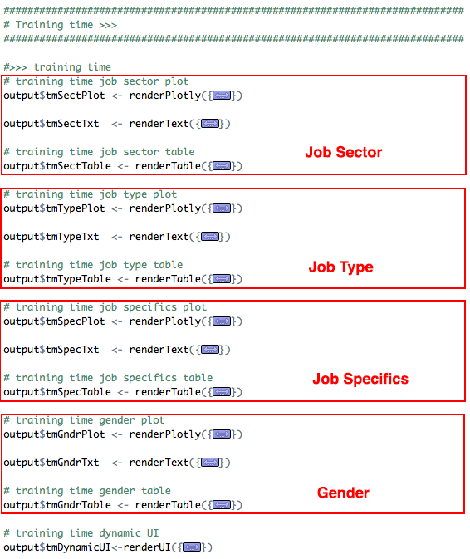

Figure 25. Code sections of training time for NIEHS data

* Training time in job sector
  + Plot – output$tmSectPlot <- renderPlotly
  + Plot text – output$tmSectTxt <- renderText
  + Data table – output$tmSectTable <- renderTable
* Training time in job type
  + Plot – output$tmTypePlot <- renderPlotly
  + Plot text – output$tmTypeTxt <- renderText
  + Data table – output$tmTypeTable <- renderTable
* Training time in job specifics
  + Plot – output$tmSpecPlot <- renderPlotly
  + Plot text – output$tmSpecTxt <- renderText
  + Data table – output$tmSpecTable <- renderTable
* Training time in gender
  + Plot – output$tmGndrPlot <- renderPlotly
  + Plot text – output$tmGndrTxt <- renderText
  + Data table – output$tmGndrTable <- renderTable
* Visualization layout of training time – output$tmDynamicUI <- renderUI

*Top 5 countries page*

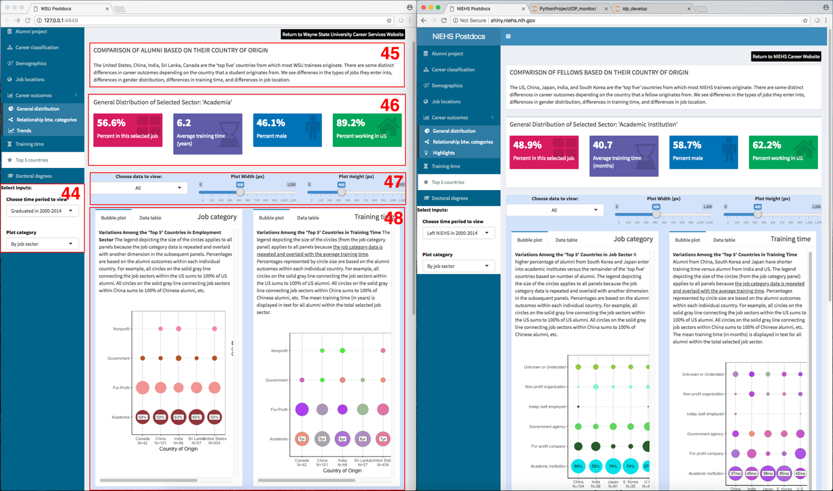

Figure 26. *Top 5 countries page*

The top 5 countries pages are very similar for WSU data and NIEHS data. The code changes are minimal.

1. Visualization selections for top 5-country data: the input selections for visualizing top 5-country data. It is a R code section in the user interface program – “ui.R.” It needs to be modified to suit the options of your data visualization (see the code section below).

NIEHS code:

conditionalPanel(

condition = "input.tabs == 'country'",

div(HTML("<strong>Select Inputs:</strong>"), style = "color:black;background-color:white;",

# select time period

selectInput("selectCtTp", label = "Choose time period to view", width="230px",

choices = c('Left NIEHS in 2000-2014',

'Left NIEHS in 2000-2004',

'Left NIEHS in 2005-2009',

'Left NIEHS in 2010-2014')),

# select plot style

selectInput("selectCtPc", label = "Plot category", width="230px",

choices = list("By job sector"=1, "By job type"=2,

"By job specifics"=3), selected = 1)

)

),

WSU code:

conditionalPanel(

condition = "input.tabs == 'country'",

div(HTML("<strong>Select Inputs:</strong>"), style = "color:black;background-color:white;",

# select time period

selectInput("selectCtTp", label = "Choose time period to view", width="230px",

choices = c('Graduated in 2000-2014',

'Graduated in 2000-2004',

'Graduated in 2005-2009',

'Graduated in 2010-2014')),

# select plot style

selectInput("selectCtPc", label = "Plot category", width="230px",

choices = list("By job sector"=1, "By career type"=2,

"By job function"=3), selected = 1)

)

),

1. Summary of top 5-country data: the brief description of top 5-country data. It is a R code section in the user interface program – “ui.R.” It needs to be modified to suit the options of your data visualization (see the code section below).

NIEHS code:

fluidRow(

box(title = "COMPARISON OF FELLOWS BASED ON THEIR COUNTRY OF ORIGIN", width = 12, solidHeader = TRUE,

paste0("The US, China, Japan, India, and South Korea are the ‘top five’ countries from which most NIEHS trainees originate.

There are some distinct differences in career outcomes depending on the country that a fellow originates from.

We see differenes in the types of jobs they enter into, differences in gender distribution, differences in training time,

and differences in job location.")

)

),

WSU code:

fluidRow(

box(title = "COMPARISON OF FELLOWS BASED ON THEIR COUNTRY OF ORIGIN", width = 12, solidHeader = TRUE,

paste0("The ", paste(top5Ctry, collapse=', '), " are the ‘top five’ countries from which most WSU trainees originate.

There are some distinct differences in career outcomes depending on the country that a student originates from.

We see differenes in the types of jobs they enter into, differences in gender distribution, differences in training time,

and differences in job location.")

)

),

1. Statistics of top 5-country data: the information box of top 5-country statistics. It is a R code section in the dashboard server program – “server.R.” It needs to be modified to match your data. The code section is too long to be listed here.

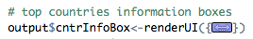

Figure 27. *Code section of information box for top 5-country statistics*

1. Plot selection for top 5 countries: the plot selections for visualizing top 5-country data. It is a R code section in the user interface program – “ui.R.” No modification is needed for this R code section (see the code section below).

NIEHS/WSU code:

div(id = "cntrPlot", style="background-color:#d4e3fc;",

fluidRow(

column(4, align="center",

selectInput("selectShowCt", label = "Choose data to view:",

choices = list("All"=1, "Job Category"=2, "Training Time"=3, "Gender"=4, "Job Location"=5), selected = 1)

),

column(4, align="center",

sliderInput("sldWidthCt", "Plot Width (px)", min = 0, max = 1200, value = 500)

),

column(4, align="center",

sliderInput("sldHeightCt", "Plot Height (px)", min = 0, max = 1200, value = 400)

)

),

1. Plots of top 5-country data: the plot for top 5-country data in different job categories, training time, gender, and location. They are four R code sections in the dashboard server program – “server.R.” These code sections are too long to be listed here.

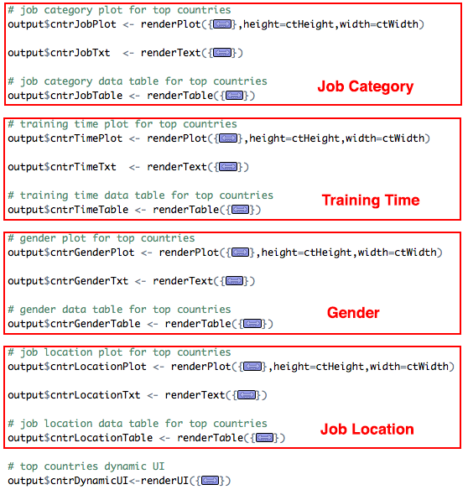

Figure 28. Code sections of top 5-country data

* Top 5-country data in job category
  + Plot – output$cntrJobPlot <- renderPlot
  + Plot text – output$cntrJobTxt <- renderText
  + Data table – output$cntrJobTable <- renderTable
* Top 5-country data in training time
  + Plot – output$cntrTimePlot <- renderPlot
  + Plot text – output$cntrTimeTxt <- renderText
  + Data table – output$cntrTimeTable <- renderTable
* Top 5-country data in gender
  + Plot – output$cntrGenderPlot <- renderPlot
  + Plot text – output$cntrGenderTxt <- renderText
  + Data table – output$cntrGenderTable <- renderTable
* Top 5-country data in job location
  + Plot – output$cntrLocationPlot <- renderPlot
  + Plot text – output$cntrLocationTxt <- renderText
  + Data table – output$cntrLocationTable <- renderTable
* Visualization layout of top 5 countries – output$cntrDynamicUI <- renderUI

*Field of study page*

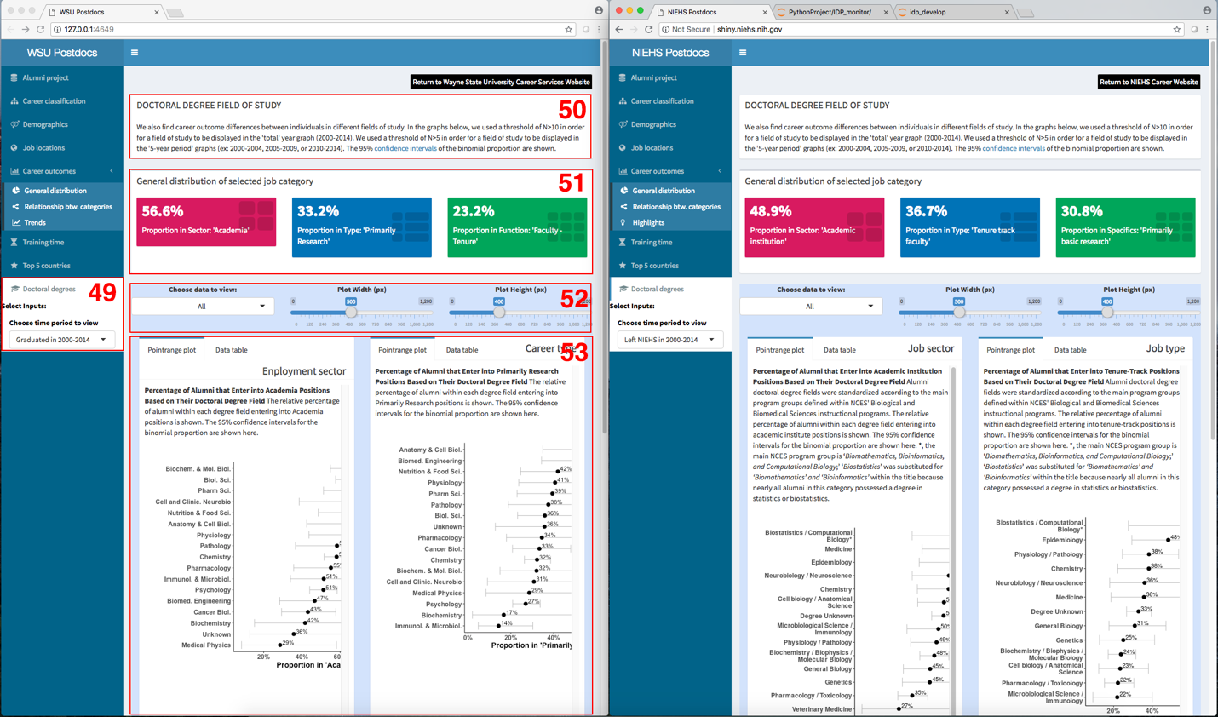

Figure 29. *Field of doctoral study*

The field of study pages are very similar for WSU data and NIEHS data. The code changes are minimal.

1. Visualization selections for field of study data: the input selections for visualizing field of study data. It is a R code section in the user interface program – “ui.R.” It needs to be modified to suit the options of your data visualization (see the code section below).

NIEHS code:

conditionalPanel(

condition = "input.tabs == 'degree'",

div(HTML("<strong>Select Inputs:</strong>"), style = "color:black;background-color:white;",

# select time period

selectInput("selectDgTp", label = "Choose time period to view", width="230px",

choices = c('Left NIEHS in 2000-2014',

'Left NIEHS in 2000-2004',

'Left NIEHS in 2005-2009',

'Left NIEHS in 2010-2014'))

)

),

WSU code:

conditionalPanel(

condition = "input.tabs == 'degree'",

div(HTML("<strong>Select Inputs:</strong>"), style = "color:black;background-color:white;",

# select time period

selectInput("selectDgTp", label = "Choose time period to view", width="230px",

choices = c('Graduated in 2000-2014',

'Graduated in 2000-2004',

'Graduated in 2005-2009',

'Graduated in 2010-2014'))

)

),

1. Summary of field of study data: the brief description of field of study data. It is a R code section in the user interface program – “ui.R.” No modification is needed (see the code section below).

NIEHS/WSU code:

fluidRow(

box(title = "DOCTORAL DEGREE FIELD OF STUDY", width = 12, solidHeader = TRUE,

HTML("We also find career outcome differences between individuals in different fields of study.

In the graphs below, we used a threshold of N>10 in order for a field of study to be displayed in the

'total' year graph (2000-2014). We used a threshold of N>5 in order for a field of study to be displayed in the '5-year

period' graphs (ex: 2000-2004, 2005-2009, or 2010-2014). The 95% <a href='https://en.wikipedia.org/wiki/Confidence_interval'>confidence intervals</a> of the binomial proportion are

shown.")

)

),

1. Statistics of field of study data: the information box of field of study statistics. It is a R code section in the dashboard server program – “server.R.” It needs to be modified to match your data. The code section is too long to be listed here.

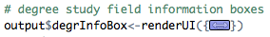

Figure 30. *Code section of information box for field of study statistics*

1. Plot selection for field of study: the plot selections for visualizing field of study data. It is a R code section in the user interface program – “ui.R.” It needs to be modified to match your data (see the code section below).

NIEHS code:

div(id = "degrPlot", style="background-color:#d4e3fc;",

fluidRow(

column(4, align="center",

selectInput("selectShowDg", label = "Choose data to view:",

choices = list("All"=1, "Job Sector"=2, "Job Type"=3, "Job Specifics"=4), selected = 1)

),

column(4, align="center",

sliderInput("sldWidthDg", "Plot Width (px)", min = 0, max = 1200, value = 500)

),

column(4, align="center",

sliderInput("sldHeightDg", "Plot Height (px)", min = 0, max = 1200, value = 400)

)

),

WSU code:

div(id = "degrPlot", style="background-color:#d4e3fc;",

fluidRow(

column(4, align="center",

selectInput("selectShowDg", label = "Choose data to view:",

choices = list("All"=1, "Employment Sector"=2, "Career Type"=3, "Job Function"=4), selected = 1)

),

column(4, align="center",

sliderInput("sldWidthDg", "Plot Width (px)", min = 0, max = 1200, value = 500)

),

column(4, align="center",

sliderInput("sldHeightDg", "Plot Height (px)", min = 0, max = 1200, value = 400)

)

),

1. Plots of field of study data: the plot for field of study data. They are three R code sections in the dashboard server program – “server.R.” They need to be modified to match your data. These code sections are too long to be listed here.

NIEHS code sections:

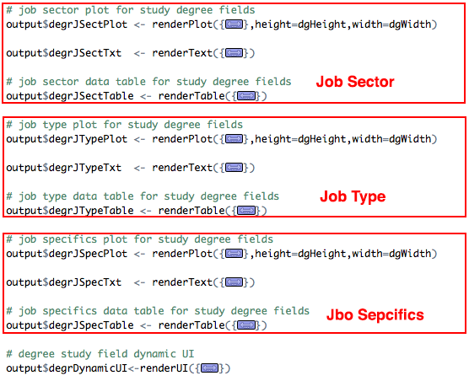

Figure 31. Code sections of field of study data (NIEHS)

* Field of study data in job sector
  + Plot – output$degrJSectPlot <- renderPlot
  + Plot text – output$degrJSectTxt <- renderText
  + Data table – output$degrJSectTable <- renderTable
* Field of study data in job type
  + Plot – output$degrJTypePlot <- renderPlot
  + Plot text – output$degrJTypeTxt <- renderText
  + Data table – output$degrJTypeTable <- renderTable
* Field of study data in job specifics
  + Plot – output$degrJSpecPlot <- renderPlot
  + Plot text – output$degrJSpecTxt <- renderText
  + Data table – output$degrJSpecTable <- renderTable
* Visualization layout for field of study data – output$degrDynamicUI <- renderUI

WSU code sections:

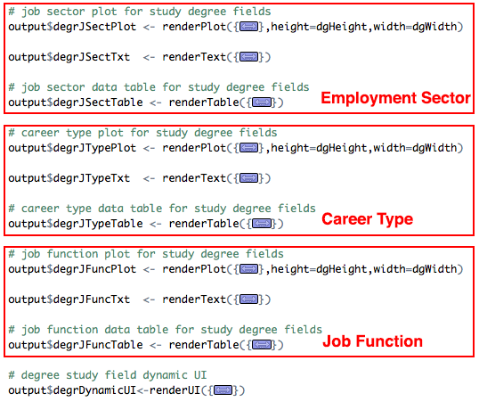

Figure 32. Code sections of field of study data (WSU)

* Field of study data in job sector
  + Plot – output$degrJSectPlot <- renderPlot
  + Plot text – output$degrJSectTxt <- renderText
  + Data table – output$degrJSectTable <- renderTable
* Field of study data in job type
  + Plot – output$degrJTypePlot <- renderPlot
  + Plot text – output$degrJTypeTxt <- renderText
  + Data table – output$degrJTypeTable <- renderTable
* Field of study data in job function
  + Plot – output$degrJFuncPlot <- renderPlot
  + Plot text – output$degrJFuncTxt <- renderText
  + Data table – output$degrJFuncTable <- renderTable
* Visualization layout for field of study data – output$degrDynamicUI <- renderUI